The inscriptions in archaic Neguev
http://bible.archeologie.free.fr/inscriptionsdesert.html
In the Neguev desert, sout-west of the Dead Sea, there is a group of very interesting inscriptions. These glyphs are mainly near Har Karkom, a place already known by its traces of human occupation in antiquity. On its rocks there are more than 130 engraved inscriptions . These glyphs could be a ancient form of semitic script [5],[6].
Important researches were led in this place in 1994 by James Harris et Dann Hone. According to us, these symbols were engraved between 1200 and 600 B.C. Their graphism is very near of proto-sinaitic et du proto-cananean script. Trying to decipher these inscriptions J. Harris was surprised to can read explicitly the name of the Israelite god : Yahweh ! The name of the god of Hebrews appears under different forms, often abbreviated : "Yah", "El Yah", "Yahu" et "Yahh". Moreover, this name is present in 25 % of the inscriptions ! In several occurrences, he is preceded by "El" which means god. There are also drawings of the seven-branch candlestick or menorah, symbol of Judaism. Most of these texts were translated : they are mainly dedications and prayers in ancient Hebrew.
According to J. Harris, the expression of god Yahve is certain. The neat archaism of some of these inscriptions and the geographical situation in Sinaï peninsula could afford to connect them to Exodus. Perhaps some day, it will be possible to ascertain they were really written by the people who followed Moses.

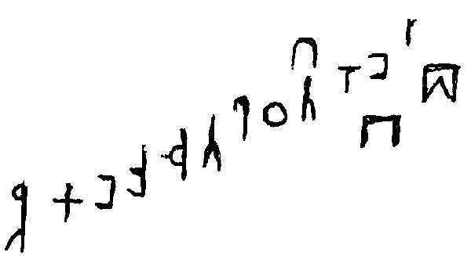 | 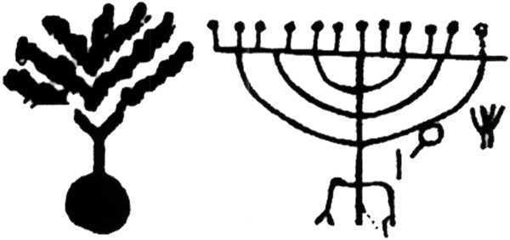

Examples of inscriptions found in Har Karkom. The one at left could means : "Bamah (cult place), spoil bring up by the door of the house of Yah.
(pictures : http://net.lib.byu.edu/imaging/negev/Names.html)
Références :
[1] - Calvet L.-J. : "Histoire de l'écriture". Plon, Paris 1996.
[2] - http://bibleprobe.com/exodus.htm
[3] - http://www.ldolphin.org/montgochron.html
[4] - http://nyjtimes.com/Heritage/News/2003/Apr/redsea2.htm
[5] - http://www.chez.com/asafu/dossiers/tifinagh.htm
[6] - http://www.lib.byu.edu/%7Eimaging/negev/
[7] - http://cryptcracker.blogspot.com

