Plato’s atlantida nesos as the “Island of Meroe”

Part II : Meroe the ancient metropolis of Kush
Thérèse Ghembaza
Independent Researcher
France

ABSTRACT
After the reign of Aspelta and the destruction of Napata by the armies of Psametik II, the new Kushite king Aramatelqo (568-555 B.C.) decided to install his royal residence in the antique metropolis of Meroe, 400 km farther to south. The so-called “Island of Meroe” today in the Sudanese province of Butana, was encircled by three rivers : the Blue Nile on the South, the White Nile on the West and its affluent the Atbara River on the North-East. According to Flavius Josephus (Antiquities of the Jews, II, 10) : “The city of Meroe was situated in a retired place, and was inhabited after the manner of an island, being encompassed with a strong wall, and having the rivers to guard them from their enemies, and having great ramparts between the wall and the rivers”. Today the ruins of the city stand 200 km north of Khartoum. The archaeological diggings began on 1909-1914 and are pursued until now but they are still greatly uncompleted. However they already allowed to discover numerous ancient buildings, several temples, and the so-called Royal Baths mentioned by Plato, as well as an important metal industry.
1. INTRODUCTION
Meroe is mentioned by the Greek and Roman authors: Herodotus, Strabo, Diodorus Siculus, Pliny the Elder, Heliodorus and Flavius Josephus (Eide, 1996, Burstein, 2000). It seems to have been a flourishing town at least as early as the 8th century BC. It was situated between the Fifth and the Sixth Cataracts at the junction of several main rivers and caravan routes, connecting central Africa via the Blue and White Niles with Egypt, and the Upper Nile region itself with Kordofan, the Red Sea and the Ethiopian highlands. Since it lays within the rain belt, the land about it was seasonally more productive than the region of Napata, and it was thus a somewhat more pleasant place to live and as well a more secure and defensible city than Napata, the previous capital of Kush. By the third century B.C. it was only one of several large towns that had arisen in the same region. Bounded to the West by the Nile, to the North by the Atbara River and to the South by the Blue Nile, this area now known as the district of Keraba, at west of the Butana province in North Sudan, was the heartland of the later Kushite kingdom, and came to be known in Greek and Roman literature as "the Island of Meroe."
The French explorer F. Cailliaud (Cailliaud, 1827) reported: “From the Atbarah River begins the Island of Meroe. The springs of this Nile affluent are close to those of Rahad its other affluent, and according to Bruce (Bruce, 1790): “On the point where the springs of Atbarah and Rahad are nearest, there is a wadi flowing east to west during the season of flood; this wadi emptied by rains realizes a perfect junction between the two rivers. So this territory becomes really an island as described by ancient authors” (Fig. 1).

2. The “Island of Meroe” in ancient authors
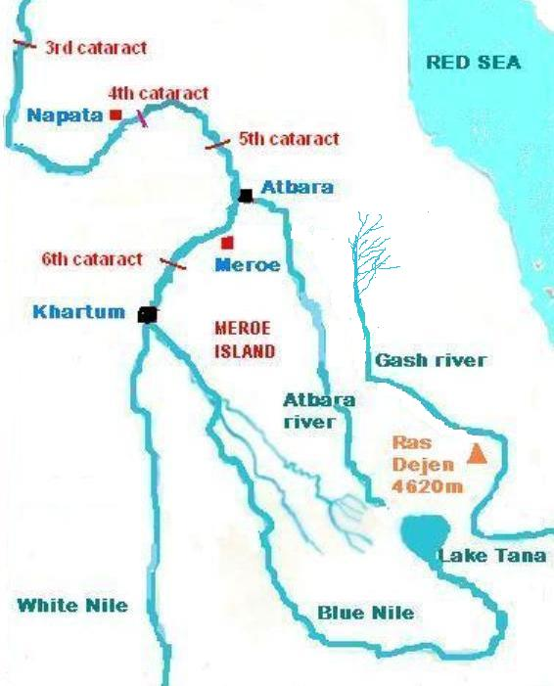

Figure 1 : Map of the so-called “Island of Meroe” in North Sudan.

We will thus consider some ancient reports about the “Island of Meroe” (see chronology of authors in Table 1) :
- Flavius Josephus in his book “Antiquities of the Jews” (Book II, chapter 10) telling that Moses reached Meroe with an Egyptian army, described the city as follows :
“The place was to be besieged with very great difficulty, since it was both encompassed by the (Blue) Nile quite round. And the other rivers Astapus (White Nile) and Astaboras (Atbara River) made it a very difficult thing for such as attempted to pass over them; for the city was situated in a retired place, and was inhabited after the manner of an island, being encompassed with a strong wall, and having the rivers to guard them from their enemies, and having great ramparts between the wall and the rivers. Insomuch that, when the waters come with the greatest violence, it can never be drowned; which ramparts make it next to impossible for even such as are gotten over the rivers to take the city.”
- And Strabo (63/64 BC – ca. 24 A.D.) in his “Geography” (Book XVII, chapter 2, 1-3) said about Ethiopians (Kushites):
“Their largest royal seat is the city of Meroe, of the same name as the island. The shape of the island is said to be that of a shield. Its size is perhaps exaggerated. Its length is about 3000 stadia (555 km), and its breadth 1000 stadia (185 km). It is very mountainous, and contains great forests. The inhabitants are nomads, who are partly hunters and partly farmers. There are also mines of copper, iron, gold, and various kinds of precious stones. It is surrounded on the side of Libya by great hills of sand, and on that of Arabia by continuous precipices.”
This description by Strabo corresponds word for word to the report of Plato (Critias 114). So it is possible that their main source was the now lost “Periegesis” of Hecataeus of Miletus (c. 550-476 B.C.), as it was also the source for Herodotus whose report (Book II, chapter 143) concerning his visit to the Egyptian priests greatly looks like that of Solon : “Hecataeus the historian was once at Thebes, where he made a genealogy for himself that had him descended from a god in the sixteenth generation. But the priests of Zeus (Amun) did with him as they also did with me (who had not traced my own lineage). They brought me into the great inner court of the temple and showed me wooden figures there, which they counted to the total they had already given, for every high priest sets up a statue of himself there during his lifetime. Pointing to these and counting, the priests showed me that each succeeded his father; they went through the whole line of figures, back to the earliest from that of the man who had most recently died. Thus, when Hecataeus had traced his descent and claimed that his sixteenth forefather was a god, the priests too traced a line of descent according to the method of their counting; for they would not be persuaded by him that a man could be descended from a god.”
- And finally Pliny the Elder (23-79 A.D.) in his “Natural History” (Book VI, chapter 35) reported: “They also state that the grass in the vicinity of Meroe becomes of a greener and fresher colour, and that there is some slight appearance of forests, as also traces of the rhinoceros and elephant. They reported also that the city of Meroe stands at a distance of seventy miles (113 km) from the first entrance of the Island of Meroe, and that close to it is another island, Tadu by name, which forms a harbour facing those who enter the right hand channel of the river. The buildings in the city, they said, were but few in number, and they stated that a female, whose name was Candace, ruled over the district, that name having passed from queen to queen for many years. They related also that there was a temple of Jupiter Hammon there, held in great veneration, besides smaller shrines erected in honour of him throughout all the country. In addition to these particulars, they were informed that in the days of the Ethiopian dominion, the Island of Meroe enjoyed great renown, and that, according to tradition, it was in the habit of maintaining two hundred thousand armed men, and four thousand artisans.” (cf. Critias 119). The whole of this country has successively had the names of Etheria, Atlantia, and last of all, Ethiopia, from Ethiops, the son of Vulcan.”
Also a modern author L. Ginzberg in his book “The Legends of the Jews” (Ginzberg, 1909) reporting rabbinic traditions about Moses in Meroe described the royal city of the Ethiopian (Kushite) king Kikanos as follows :
“On two sides they made the walls higher, on the third they dug a network of canals, into which they conducted the waters of the river girding the whole land of Ethiopia, and on the fourth side their magic arts collected a large swarm of snakes and scorpions. Thus none could depart, and none could enter.”

Table 1 : Chronology of ancient authors

Authors Life Time
- Solon in Egypt circa 561 B.C. 638 – 558 B.C.
- Hecataeus of Miletus “Periegesis” 550 – 480 “
now lost, but probably the main source of Plato and Eratosthenes
- Herodotus (II, 143) : 482 – 425 “
Hecataeus also met Egyptian priests
- Plato : Atlantis (Critias) 427 – 348 “
- Eratosthenes (reported by Strabo XVII, 2: 1-3) 276 – 194 “
The same description of Meroe as Plato for Atlantis
- Diodorus Siculus 90 - 30 “
- Strabo 57 B.C. - A.D. 25
- Pliny the Elder : Atlantis = Ethiopia A.D. 23 - 79
- Flavius Josephus : Moses in Meroe (c. 1500 BC) A.D. 37 – 100
- Proclus : Three big islands near the Straits A.D. 412 - 485

3. THE ARCHAEOLOGY OF THE CITY OF MEROE AND NEARBY
Perhaps you are now waiting to hear that the excavations in Meroe allowed to discover the exact model of triple concentric circles alternating land and water as described by Plato. For the moment we must be patient and stay realistic taking only in account the archaeological and geographical characteristics of the city of Meroe and its region. It is also important to consider that until now only thirty per cent of the site were investigated.
The city stood on the right bank of the Nile 200 km north of Khartoum. Describing its actual state the archaeologist T. Kendall (Kendall, 2007) said: “Today Meroe is the largest archaeological site in Sudan. Lying about a half a mile (800 m) from the river, the city ruins alone cover about a square mile (2 km²) in area. Most prominent among the ruins is the huge stone walled enclosure containing the rubble remains of the palace and government buildings, several small temples (one with painted frescoes), and a so-called "Roman bath" or nymphaeum. Immediately behind it sprawls another walled compound enclosing the Amun Temple, a near copy of the one at Gebel Barkal. The remains of several other major sanctuaries lie nearby among the trees. Between these and the palace compound there are the extensive unexcavated mounds of the settlement, and on the east end of the city, on the edge of the desert, there are great slag heaps which have suggested that Meroe was an important iron working centre “ (Kendall, 2007).
The royal enclosure had numerous buildings, such as two square palaces, an audience hall, and baths that must have belonged to the palace complex. Animal bones suggest also an area of outdoor slaughter and P. Lenoble emphasized in 1994 that the sacrifice of cattle was a characteristic of Meroe (Fig. 2).
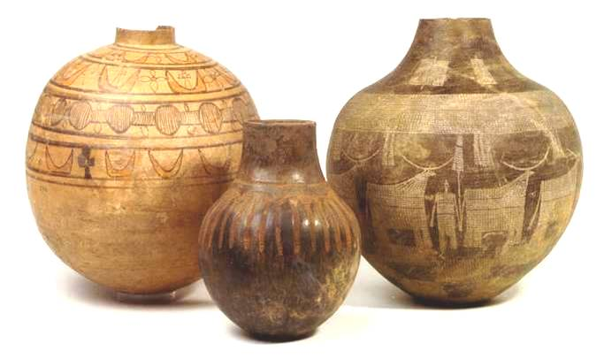

Figure 2 : Painted pots with double horns and bulls found in Meroe.

As you can see on figure 3, the main buildings of the royal enclosure were two similar square palaces and the so-called Royal Baths at west. This area was surrounded by a big rectangular wall of dressed blocks (3.5 m to 7.75 m of thickness). There were towers in each corner and gates of the wall. East of this area and backed to the wall was the big Amun temple (Török, 1997). There was an evidence of destruction at the south-west corner of the enclosure wall by an undated catastrophe (Bradley, 1982). This author suggests that it was caused by an unusually high flood which has reached the side of the farthest settlement mound at East.
Each palace M294 and M295 (Fig. 4) measured 40 x 40 meters. There are traces of staircases which suggest there must have been upper floors. A cache found in M294 yielded many objects of high quality which could be the votive deposit of an earlier Amun temple standing on an island representing the primeval hill itself. The actual palace M294 was thus built in the late 6th century B.C. over an earlier sacred precinct (as Plato said in Critias 115) (Bradley, 1984).
The Royal Baths (Fig. 5, 6 and 7) mentioned by Plato (Critias 117) were in an extensive building with a big square water basin of 7.5 m of side and depth of 2.5 m, easy to enter by a staircase. Three sides of the basin are surrounded by a column-flanked passage; the fourth side is marked by an uprising show-wall. From this side the basin was supplied with water flowing through several covered pipes. At this side the splendid and colourful decoration of the building is still well preserved: sculptures of sandstone, faience wall-inlays and painted plaster. The edges of the basin were marked by bull and lion heads. Furthermore, statues of up to life-size were placed within the building, as the discovery of several statues in the water-basin shows. Although the decorations of the actual remains made of red bricks were dated from the Graeco-Roman period, the ancient building could be a water sanctuary dating of the earliest Napatan kingdom (8th century B.C.) (Bradley, 1982). At that time, the basin was fed by a pipe coming from the South and the evacuation was from the bottom by an arched aqueduct running from West to East under the wall of the city towards the Nile.
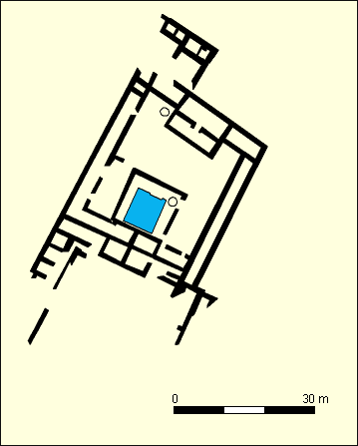
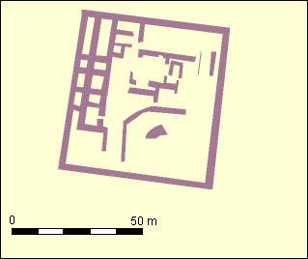
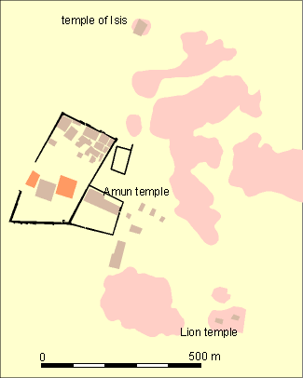

Figure 3: Map of the city of Meroe Figure 4 : The royal palace M294 Figure 5 : The Royal Baths
In this respect we must consider that for Libyan people Amun was a god of water and soil fertility, as well as for Ammonians of Siwa oasis north-west of Egypt, where pharaoh Amasis built a big Amun temple (Laronde, 1993). In Meroitic temples Amun was often associated with Hapy the Egyptian genie of the Nile inundation. An exceptional high flood of the Nile was recorded in the 6th year of Taharqa, for which the king thanked very much god Amun as his own father (Vikentiev, 1930).

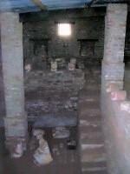
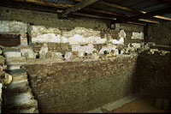
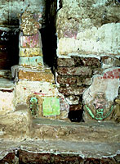

Figure 7 : Musician with a Pan-flute at the side of the show-wall.
Figure 6 : The great water-basin with stairs in the building of the Royal Baths.

It is supposed that the earliest city in Meroe was built on three alluvial hills, as at north-east and south-east of the royal enclosure are several mounds not yet completely investigated. However there are indices that the north mound had been inhabited as early as the 8th century B.C. According to the archaeologist R. Bradley (Bradley, 1982) a canal had encircled the three hills and another wall or dam outside the canal had protected the city against the Nile floods.
And finally as described by T. Kendall (Kendall, 2007) : “Behind the city in the eastern desert lie its vast cemeteries. Those nearest the town were reserved for the common people… About three miles away (5 km), lining the tops of two ridges, are the towering pyramids of the rulers, of which over forty can be counted. But until 280 B.C. the kings of Meroe were still buried in Nuri near Napata. That is why neither Plato, nor Strabo mentioned the pyramids of Meroe, as when Hecataeus of Miletus visited the city in the 6th century B.C. not any pyramid yet existed in Meroe.

4. GEOGRAPHICAL ENVIRONMENT
The plain of Meroe on the right bank of the Nile is protected from the north wind by a low but massive round mountain Djebel Amia (400 m of height), from which descends a river Wadi Mukabrab. In its first course it flows north towards the Atbara River, but obviously its course was willingly reoriented by man towards west to go to the Nile by means of a big earthen dam. By this way its lower course flows east to west (instead of south to north) closing the entry of the plain of Meroe by north. South of the city another tributary of the Nile, Wadi El Awad, protected the other access to the plain and by its long course it connected Meroe with the inland of Butana. Perhaps these two wadis correspond to one (the third one ?) of the three water enclosures described by Plato (Fig. 8).
According to S. Wolf (Wolf and Onasch, 2003 ; Wolf, 2008) and H.-U. Onasch (Onasch, 2008) of the German Archaeological Institute of Berlin, massive water channel systems were recently discovered in the area of the Royal Baths, one of them being independent of the baths. A team of the Department of Archaeology of Khartoum University (Ali Osman, 2008) is now planning to perform a detailed study of the wadi systems around Meroe. These recent developments were exposed in the 11th International Conference for Meroitic Studies held in Vienna on September 1-4, 2008.
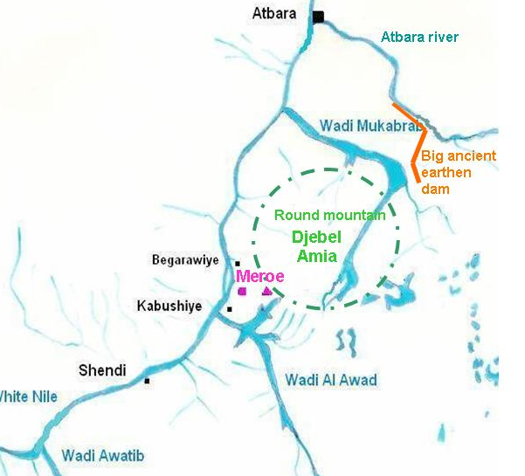

Figure 8 : The geography of Meroe area

And according to Pliny the Elder (N.H. Book VI, chapter 35) there was a harbour on the Nile in front of Meroe. At the actual stage of digging it was not detected (but perhaps nobody was looking for it). However, the harbour described by Plato looks like the Meroitic site of Wad ben Naqa 80 km upstream from Meroe. This ancient settlement on the right bank of the Nile was located between two branches of the now fossil Wadi Kirkeban allowing to reach by water the two big ancient Meroitic cities of Naqa and Musawwarat es Sofra built on the plain some twelve to eighteen miles (20 to 30 km) inland.
Moreover an important mining activity existed in Upper Nubia in ancient times : mainly the extraction of gold and iron (Vercoutter, 1993). But there could be also possibly a production of “orichalkos gleaming as fire”. This one according to Pliny (N.H. Book 34, chapters 2 and 20), was an alloy of copper and gold also named pyrope. It is presently called auricupride (Cu₃Au) and found at natural state (although in small quantities) in South Africa and in a Russian Urals region named Karabash (cf. Keraba in Sudan).
In Meroe a crucible used for smelting copper-alloy was found associated with an area of iron working. East of the north necropolis, there were big quarries with large pillars (Welsby, 1996).

5. other meroitic settlements
Moreover, as T. Kendall (Kendall, 2007) said : ”If Meroe was the major city of the kingdom, it was not the only one. The Butana steppe is dotted with other Meroitic remains, some up to sixty miles (100 km) east of the Nile. Other settlements have been identified further south along the Blue and White Niles, and many Meroitic settlements arose in Lower Nubia, some barely a hundred miles (160 km) south of Aswan.

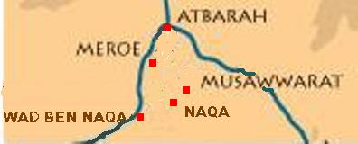

Figure 9 : Main archaeological sites of the region of Meroe (District of Keraba province of Butana)

Apart from the capital, the most monumental sites in Butana are three, which lie between forty and fifty miles (between 65 and 80 km) south of Meroe (Fig 9).
- At Wad Ben Naqa, on the east bank of the Nile, there may be seen the remains of an enormous palace, together with two temples and a town. This was apparently a river port.
- Musawwarat es Sofra, ten miles (16 km) to the North, was also a cult centre and perhaps, too, a caravanserai. The most spectacular site in the Butana, Musawwarat contains the sprawling ruin known as the "Great Enclosure", a labyrinth of stone buildings, temples, corridors, ramps, and courtyards. Zodiac figures sculptured on the basis of a column (now disappeared) have suggested that there was an astronomical observatory (Cailliaud, 1822). Tremendous stone walls partitioned the complex into no less than twenty separate compounds, which have recently been found to be protected gardens of fruit trees, all brought together with their appropriate soil from the banks of the Nile and watered by an elaborate underground pipe system. Numerous representations of elephants lead to propose that there was also a centre for the training of elephants for war (Fig. 10).
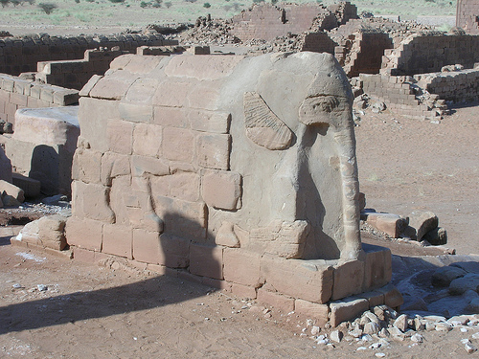

Figure 10 : An elephant as a column in Musawwarat
- The site of Naqa was clearly an important religious centre, for it possesses the ruins of seven stone temples, a town, and a cemetery. Its Apedemak temple is adorned with reliefs depicting the imposing figures of its builders, king Natakamani and queen Amanitore, doing homage to the lion god. This royal pair, who lived at about the time of Christ, seems to have presided over a Meroitic "Golden Age," as the remains of numerous buildings bear their names. On-going excavations here have revealed that the town was also surrounded by numerous manor houses with plantations (Wildung, 2006).
While both the sites of Naqa and Musawwarat now are in virtual desert, careful management of somewhat greater rainfall in ancient times made the area much more fertile than it is today. Huge hafirs (catch-basins) were constructed at each site to collect the annual rainwater and keep it until needed. The largest hafir at Musawwarat is 800 ft. (243 m) across and 20 ft (6 m) of depth. Stone statues of guardian lions and frogs ringed many of these artificial lakes magically protecting their contents.
The major god of the region of Meroe was a divinity of local origin, called Apedemak (Winters, 2005) (Fig. 11). He was often identified with the moon. He normally took the form of a powerful lion-headed man, dressed in armour. He usually appeared in the reliefs of his temple in a warlike aspect, standing or seated on a throne or on an elephant, grasping prisoners and weapons of war, or holding elephants and lions on leashes. Magnificent temples in his honour were built at every major site in the Butana. Apedemak could be a warrior hero benefactor for the region in ancient time (perhaps Thuthmose Ist) who had been deified (as suggested by Diodorus, Book III, 8, 9).

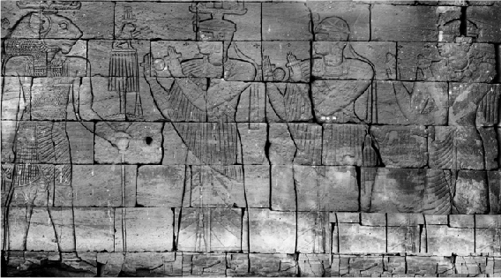
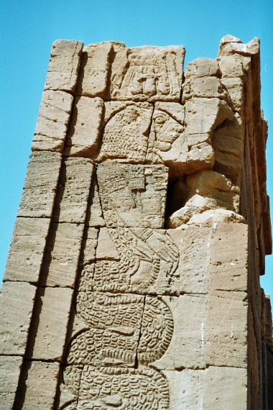

Figure 11 : God Apedemak : a man with a lion head and sometimes with a snake tail.

6. CONCLUSIONS
The archaeological discoveries in the city of Meroe and its geographical environment lead us to consider the consistency of this very particular frame with the description of Atlantis by Plato.

REFERENCES
Ali Osman, M.S. (2008) The archaeology of greater Meroe. In: Abstracts of 11th International Conference for Meroitic Studies, Vienna, Austria, September 2008.
http://www.univie.ac.at/afrikanistik/Meroe2008/abstracts/Abstract%20Ali%20Osman.pdf
Bradley, R. (1982) Varia from the city of Meroe. Meroitic Studies MEROITICA (Berlin) 6, 163-170.
Bradley, R. (1984) Meroitic chronology. Meroitica 7, 195-211.
Bruce, J. (1790) Travels to discover the source of the Nile by James Bruce of Kinnaird, Edinburgh, London : G. G. J. Robinson.
Burstein, S.M. (2000) The origins of the Napatan state in classical sources. In: Meroitic Studies MEROITICA (7th Internat. Tagung für Meroitische Forschung), pp. 118-126. Berlin.
Cailliaud, F. (1822) Extrait de ses 6e et 7e lettres à M. Jomard. In: Nouvelles Annales des Voyages, de la Géographie et de l’Histoire. Tome XVI, Paris, Gide. pp. 128-129. http://www.archive.org/stream/nouvellesannales16parr#page/128/mode/1up
Cailliaud, F. (1826-1827) Voyage à Méroé, au Fleuve Blanc au-delà de Fazoql, dans le midi du royaume de Sennâr, à Syouah, et dans cinq autres oasis : fait dans les années 1819, 1820, 1821 et 1822. T. 2 / par M.,... ; [rédigé par F. Cailliaud et E.-F. Jomard], Paris: Imprimerie Royale.
Eide, T., Hagg, T., Pierce, R.H. and Török, L. (1994-2000) Fontes Historiae Nubiorum. Textual sources for the history of the Middle Nile Region between the eighth century BC and the sixth century A.D., Bergen, Sweden.
Ginzberg, L. (1909) The Legends of the Jews, Book 2, part III. http://philologos.org/__eb-lotj/
Kendall, T. (2007) http://numibia.net/nubia/meroe.htm
Laronde, A. (1993) Zeus-Ammon en Libye. Hommages à Jean Leclant (B. d. E.) 106, 331-338.
Lenoble, P. (1994) Le sacrifice funéraire de bovinés de Méroé à Qustul et Ballana. In: Hommages to Jean Leclant T. II, Bibliothèque d’Etudes, IFAO, Le Caire. pp. 269-283.
Onasch, H.U. (2008) The water system of the Royal Baths at Meroe. In: Abstracts of the 11th International Conference for Meroitic Studies, Vienna, Austria.
http://www.univie.ac.at/afrikanistik/Meroe2008/abstracts/Abstract%20Onasch.pdf
Török, L. (1997) Meroe city : an ancient African capital. John Garstang's excavations in Sudan. Part I (Text), Part II (Figures and Plates), London: The Egypt Exploration Fund.
Vercoutter, J. (1993) Or et politique dans l'Egypte des origines. In: Hommages à J. Leclant, B. de E., pp. 403-410.
Vikentiev, V. (1930) La haute crue du Nil et l'averse de l'an 6 du roi Taharqa. Recueil de Travaux 4e fascicule, 1-59
Welsby, D.A. (1996) The Kingdom of Kush. The Napatan and Meroitic empires, London: British Museum Press.
Wildung, D. and Kroeper, K. (2006) Naga - Royal City of Ancient Sudan. Berlin, Staatliche Museum zu Berlin - Stiftung Preußischer Kulturbesitz.
Winters, C. (2005) Meroitic religion. Arkamani Sudan Electronic Journal of Archaeology and Anthropology, October 2005. http://www.arkamani.org/arkamani-library/meroitic/meroitic-religion.htm
Wolf, S. (2008) The Royal Baths at Meroe : recent investigations. In: Abstracts of the 11th International Conference for Meroitic Studies, Vienna, Austria.
http://www.univie.ac.at/afrikanistik/Meroe2008/abstracts/Abstract%20Wolf.pdf
Wolf, S. and Onasch, H.U. (2003) Investigations in the so-called Royal Baths at Meroe in 1999. A preliminary report. Kush 18.

