Plato’s atlantida nesos as the “Island of Meroe”

Part I : The reason why Egyptians were so friendly with the Greek Solon
Thérèse Ghembaza
Independent researcher, France

ABSTRACT

As early as the second millennium, Kush (Upper Nubia) and Egypt were in perpetual rivalry for the domination of the Nile valley. The pharaohs of the 12th dynasty had to build several big fortresses to protect their south frontier against attacks of the Kushite kingdom of Kerma. During the Second Intermediate Period, Kerma rulers were allied to Hyksos to strangle the frail Theban kingdom. They were defeated by Kamose circa 1550 B.C. Then, after recovering Lower Egypt from Hyksos, pharaohs of the 18th dynasty finally subdued the kingdom of Kerma in order to avoid further attacks from South.

But after the ramesside era, the influence of Egypt on Kush diminished whereas autochtonous rulers gained more and more power. So that in 741 B.C. Piankhy a Kushite king originating from Napata invaded Egypt as far as Thebes, then submitted the delta. It was the first of the black pharaohs of the 25th dynasty who reigned on Egypt for seventy-five years, before to be expelled by the Assyrian king Assurbanipal. However after retreating to Napata, the Kushite rulers continued to threat the south frontier of Egypt. Finally, in 593-591 B.C. pharaoh Psametik II of the 26th dynasty helped by Greek mercenaries made a victorious military campaign against Kushites. Napata the sacred city of Kush was burnt, so Kushites decided to move their capital to their ancient metropolis of Meroe.

The reason why the Sais priests reported this glorious event to Solon was the project of pharaoh Amasis to obtain a new military alliance with Aegeans to contain the imminent Persian threat on Egypt.

1. INTRODUCTION
Firstly we need to investigate the Plato’s text in connection with the issue of why the Egyptians of the 6th century B.C. received Solon so friendly :
"Solon said that, when he travelled to Sais, he was received with much honour; and further that, when he inquired about ancient times from the priests who knew most of such matters, he discovered that neither he nor any other Greek had any knowledge of antiquity worth speaking of. Once, wishing to lead them on to talk about ancient times, he set about telling them the most venerable of our legends, about Phoroneus the reputed first man and Niobe, and the story how Deucalion and Pyrrha survived the deluge.” Plato, Timaeus, 21-22.
In 1978 J. V. Luce citing the Phaedrus of Plato wrote: “It confirms that Plato was well informed about the religion and history of Egypt. But he would have had no way of synchronizing Egyptian historical data with the legendary past of his own country”. As for us, we wish to demonstrate that such a link did exist. Indeed, thirty years before the visit of Solon, Egyptians together with Greeks soldiers have vanquished the powerful kingdom of Kush in Upper Nubia (actual North Sudan). And it is not a coincidence if Egyptians recalled to the Greek the mythological tales of Phoroneus, Deucalion and Pyrrha. As in a euhemeristic view, these persons had been important actors in Egypt history before to come to Greece.

2. Kush the millenary enemy of Egypt

2.1 The first people of Upper Nubia

The Kingdom of Kush was one of the earliest civilizations to develop in the Nile Valley. Having also been referred to as Nubians, and as "Ethiopians" in ancient Greek and Greco-Roman records, the Kushites left their mark on various aspects of the ancient world and their legacy is still readily discernible from the various archaeological field sites scattered throughout modern Sudan.

From earlier semi-nomadic tribes, the "A-group" emerged in lower Sudan around 3800 B.C., and was contemporary with the pre-dynastic Naqada people of Upper Egypt, sharing an almost identical culture. After the demise of the A-group, the culture called the "C-group", who founded the Kingdom of Kush began to appear consistently in Egyptian accounts and the archaeological records.

2.2 The powerful kingdom of Kerma

As early as the Middle Kingdom Egypt had to fortify its South frontier against Kushite attacks. Sesostris III 5th pharaoh of the 12th dynasty made several campaigns in Upper Nubia and built enormous strongholds in Semneh, Mirgissa and Buhen on either side of the Nile close to the Second Cataract. His powerful enemy was the kingdom of Kerma (2500 B.C. to about 1520 B.C.) which spread from south of the Third Cataract at least as far as the Fourth Cataract. The city of Kerma above the Third Cataract of the Nile included both an extensive town, a huge temple named Deffufa (Fig. 1) and a cemetery consisting of large tumuli (Fig. 2). Early Kerma society was agricultural in nature and had round hut dwellings with distinctive circular tombs. Later Kerma developed into a foreign trade-based society with mud-brick architecture, dealing in ivory, diorite, and gold (Bonnet, 1995).

During the Second Intermediate Period, the ruler of Kerma was allied to the Hyksos king Apophis to strangle the frail kingdom of Thebes. However he was defeated by king Kamose of the 17th dynasty circa 1550 B.C. But after recovering Lower Egypt from Hyksos, pharaohs of the 18th dynasty finally subdued the kingdom of Kerma in order to avoid further attacks from South. From the reign of Ahmose (I) the Land of Kush was administered by a viceroy vassal of Egypt. Thuthmose Ist reached the Fifth Cataract and Thuthmose III built a temple in Djebel Barkal the sacred city of Kush. This temple was later embellished by the Ramses of the 19th dynasty. But after the last ramesside king, the power of Egypt on Kush collapsed and finally a new dynasty of autochtonous rulers emerged in the region of the Fourth Cataract.
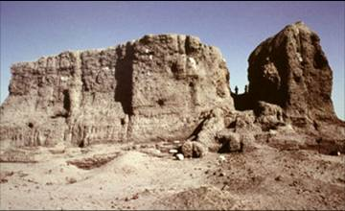
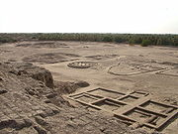

Figure 1 : The Deffufa of Kerma Figure 2 : View of the city of Kerma

2.3 The black pharaohs come from Napata

At Napata the royal city of Kush just before the Fourth Cataract of the Nile, Djebel Barkal “the pure mountain”, a tabular hill of 100 m high stands on the right bank of the Nile. It has a pinnacle in the shape of an aureus snake up crowned with the sun disk. In the mind of Kushite people Amun their dynastic god dwelled under this mountain (Fig. 3). Numerous temples and royal palaces were built at the bottom of the mountain further become the city of Napata. On the right bank of the Nile, 13 km south from Djebel Barkal is the necropolis of El-Kurru (Fig. 4). Here are the pyramids of 9 kings and 14 queens of the 25th dynasty of Napata. After 656 B.C. a new necropolis was settled in Nuri on the left bank of the Nile. Here are the pyramids of 21 kings and 52 queens mainly coming from Meroe the latest capital of Kush. These two big necropolis and two other ones in Meroe are witnesses to the power and longevity of the Kushite dynasties.
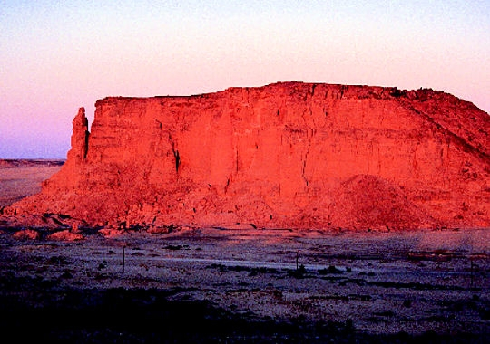

Figure 3 : Djebel Barkal at Napata the sacred city of Kush with god Amun and goddess Mut dwelling
under the mountain (Amun temple B300).

Mainly, in 747 B.C. king Piankhy (also translated as Piye) coming from Napata conquered Egypt as far as Memphis, then submitted the delta. He was the founder of the 25th dynasty (760-656 B.C.) whose black pharaohs reigned on both Nubia and Egypt wearing a double aureus on their crown. A son of Piankhy, Taharqa reigning in Memphis (690-664 B.C.) spread his empire from Khartum to Lebanon in the North, as far as Altava in West Algeria through Cyrene and Tunisia (and according to Strabo V, 2, 2 as far as Etruria which is Tyrrhenia). He reigned thus for twenty years on the largest empire ever created on the Nile in ancient times.

But in 656 B.C. a son of Taharqa, Tanutamun the last pharaoh of the Kushite 25th dynasty, was expelled from Egypt by the Assyrian king Assurbanipal. His brother and successor Atlanersa reigned only on Upper Nubia from his residence of Napata (Fig. 5).
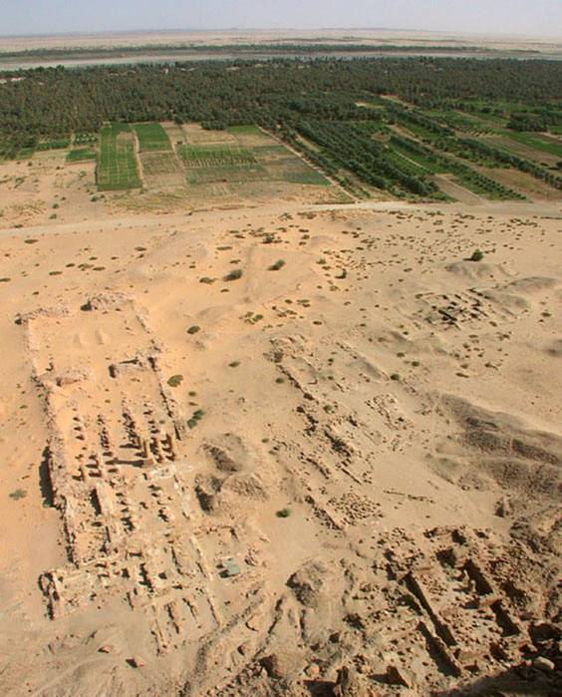
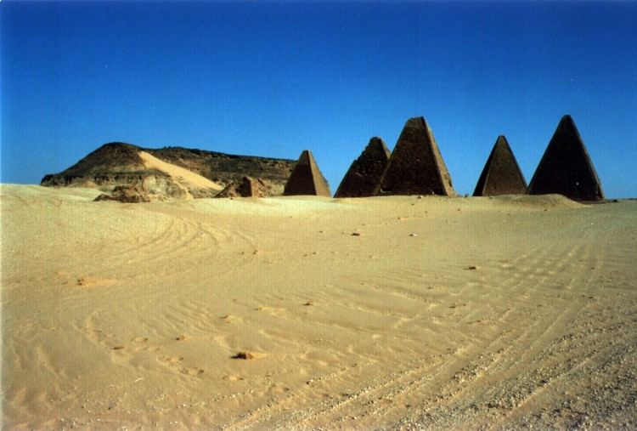

Figure 4 : Pyramids of El Kurru in front of Djebel Barkal Figure 5 : The temples of Napata

3. THE VICTORIOUS CAMPAIGN OF PHARAOH PSAMETIK II

3.1. Description of the campaign

However the bellicose kingdom of Napata continued its attacks against the south borders of Egypt. Pharaoh Psametik Ist of the 26th dynasty in Saïs had to maintain a garrison of 250 000 soldiers to guard his frontier in Elephantine near the First Cataract. Herodotus (II, 30) reports that as they were not replaced for three years these soldiers deserted and passed to the service of the king of Kush who gave them a land to install after they drove out the previous inhabitants who were his enemies.

Finally, his grandson Psametik II (595-589 B.C.) hearing that Kush intended to attack Egypt one time more, decided to quell this recurrent problem by a radical military campaign. General Amasis conducted the Egyptian troops, which were reinforced by a corps of Greek mercenaries led by general Potasimto (Lefebvre, 1925; Sauneron and Yoyotte, 1952; Grimal, 1988a; Török, 1997; Bonnet and Valbelle, 2005).
Three steles in hieroglyphs found in Shallal (now exposed in Kalabsha), Karnak and Tanis (Der Manuelian, 1984) report this expedition which spread from 593 to 591 B.C (Fig. 6). The king himself stopped in Elephantine at the level of the First Cataract at Aswan.
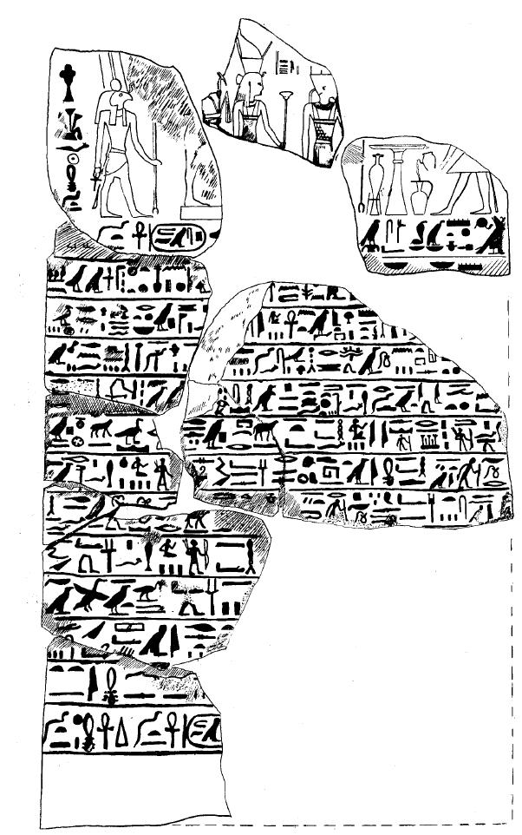

Figure 6 : Psametik II’s stele found in Tanis (drawn from a photograph).

The stele of Tanis reports that Psametik II sent an army to “the Land of Chas” where was the residence of the Kushite king near the city called “the Cliff”. A great carnage was made there. The king was burnt (probably in his palace) and the soldiers cut the fruit trees in the kings’ orchard. The rest of the stele is damaged (Fig. 6). T. Kendall as an archaeologist specialist of Napata emphasizes that “the Cliff” could not be another place than Djebel Barkal where many temples were destroyed by fire (Kendall, 2002). Then the troops continued along the Nile valley and after several battles reached Kerkis “as far as the river allowed” (Fig. 7). The other steles of Karnak and Shellal record a victory at Pnubs (actual Doukki Gel) south of the Third Cataract, in which the Egyptian army took 4200 prisoners.
But Kerkis could be Kurgus, well beyond the Fourth Cataract, not so far short from Meroe (Ratie, 1962 and Figure 7), this last city which was soon to become the capital of the Nubian kings, probably as a result of the success of this Egyptian expedition (Bernand and Masson, 1957; Goedicke, 1981; Kendall, 2002; Sartre 2009).
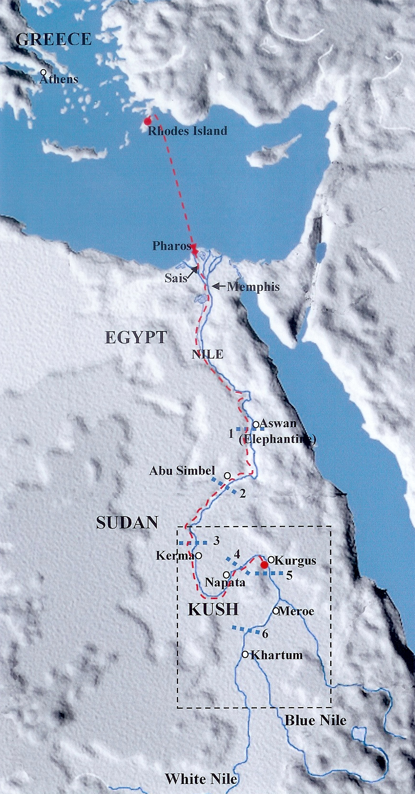
Cataracts of the Nile
Itinerary of the troops
Figure 7 : Map of the Nile cataracts : Abu Simbel is just above the Second Cataract
and Kurgus (possible Kerkis) is just above the Fifth Cataract.

On their return to Egypt, the troops halted at the Second Cataract and camped at the rocky temple that Ramses II had had built at Abu Simbel at the beginning of the 13th century, nearly seven centuries earlier (Abu Simbel is about 140 km south of Elephantine). There a graffiti engraved in Ionian script by Greek-speaking soldiers on the left leg of one of the four colossi of Ramses II attests to the passage of the armies (Sauneron and Yoyotte, 1952) (Fig. 8 and 9).
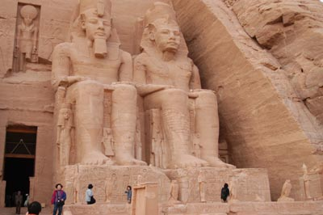
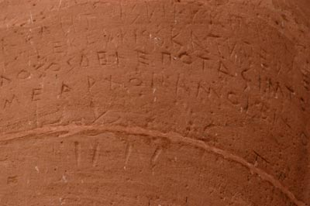

Figure 8 : Photographs of the Ramses II’ colossi of Abu Simbel with the Greek graffiti on one leg.
(From http://www.phouka.com/tr/egypt/photos/abuSimbel/ramesses-02.html)
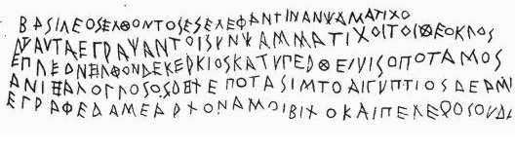
Figure 9 : First fac-simile of the Abu Simbel graffiti by Lepsius in ”Denkmäler aus Ägypten und Äthiopien“, 1850, plate 99.
This inscription is one of the earlier texts in Greek language (6th century B.C.). The dialect is Doric, probably Rhodian, in largely Ionian script. The length of the lines is 2.12–2.80 m, the height of the letters is 4-8 cm. The letters of this alphabet are very similar to those of the inscription of king Mesha of Moab (9th century B.C.) which used a Phoenician alphabet to write Hebrew (Taylor, 1883). Here is a modern Greek transcription of the Abu Simbel inscription (Dillon, 1997) :
“When king Psametichos came to Elephantine, those who were sailing with Psammetichos son of Teocles wrote this : they came upper stream from Kerkis as far as the river allowed ; and Potasimto commanded those who spoke a foreign language, and Amasis (commanded) the Egyptians ; (this was) engraved by Archon son of Amoibichos and Pelekos son of Oudamos.”
The troops included two very different elements : Egyptians led by general Amasis, and mercenaries of foreign origin, especially Greeks, led by general Potasimto. The captain of the troops was a certain Psammetichos, homonym of the pharaoh, but he must have been of the second-generation Greek, for his patronymic, Theocles, vouches for his foreign origin. Certainly he was the pilot who guided the navigation on the Nile. But Pelekos was not a man’s name but an actual military weapon “Pelekos=axe” and of course was the son of “Oudamos=nodoby”. With that weapon, the pelekos, soldier Archon engraved the text. It is a pun, a Greek joke coming from 2600 years ago ! Dillon in 1997 remarked that this spun was already used in Homeric time by Odysseus wishing to conceal his identity to the Cyclops and telling him “My name is Outos” = Nobody (Odyssey IX, 366, 369, 408, 455, 460).
Other graffiti can be read on the same leg and another on the knee of the second colossus at the far left of the façade of the temple. They clearly belong to the same period and to the same group: one bears the name of Python son of Amoibichos, unquestionably Archon’s brother. They supply precious information, for several include an “ethnikos”. Thus Telephos of Ialysos (one of the three cities of Rhodes) left his name, along with Helesitios of Theos, Pabis of Colophon, and Anaxogoras of Ialysos. They clearly came from Asia Minor.
These Greeks at the service of Egyptian kings at the beginning of the 6th century B.C. were in the company of other mercenaries of various regions: Carians, Syrians and Jews. According to Herodotus (II, 134) pharaoh Apries, successor of Psametik II, employed thirty thousand Greek mercenaries in his army when he was beaten by the usurper Amasis in 569 B.C. Let to recall the proximity between the Aegean world and Egypt. All indications converge: it took only five days to go from Crete to Egypt, and barely four from Rhodes to the entrance of the delta, in good weather. But from Rhodes Island to Kurgus the way by sea, by earth and then by the Nile was of about 2900 km (Fig. 7) explaining why the campaign lasted three years.
First Greek mercenaries have been settled in the delta by Psametik I, not far from the sea, in a place that Greeks called Stratopeda “the camps”: they were charged to train young Egyptians and teaching them Greek language. And according to Herodotus (II, 160), Psametik II had received an ambassade of Eleans concerning the rules to apply to Olympic Games. (Bernand and Masson, 1967, Westmann, 1990; Sartre, 2009).
Psametik II celebrated his victory with glare and great pomp (Fig. 10), but curiously he does not appear to have capitalized on his victory. His troops retreated back to the First Cataract, and Elephantine continued to be the southern border of Egypt. An outcome of this campaign was the deliberate destruction of monuments belonging to the 25th dynasty of Kushite kings in Egypt "by hacking out their names and the emblems of royalty from their statues and relieves." Later, in 590 B.C. during the fourth year of his reign, Psametik II launched an expedition into Palestine "to foment a general Levantine revolt against the Babylonians" that involved, among other, Zedekiah of the Kingdom of Judah. Then he died a little time after.
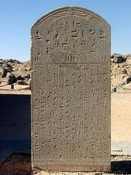

Figure 10 : Psametik II’s Shellal stele now exposed in Kalabsha.
(From http://www.flickr.com/photos/10647023@N04/ (by courtesy of Mr. John Campana)
As a result of Psametik II's devastating campaign, Kush power was crushed, and its kings from Aspelta onwards lost any opportunity of ever regaining control of Egypt. Instead, the Nubian rulers decided to shift their capital further South from Napata to their ancient metropolis of Meroe (Fig. 7).
3.2 The biography of general Potasimto
3.2.1 His Egyptian name
The name of this Egyptian general written in hieroglyphs is Padi-sema-tawi : « Gift of the one who unifies the Two Lands (Ratie, 1962.) (Fig. 11). As early as 1883, the linguist Isaac Taylor said about the Abu Simbel graffiti that perhaps in Greek we should read the name of general Potasimto: πότάς‮‮ίπτο (pota for “padi” and simto for “sematawi”).
Figure 11 : “Padisematawi born by lady Tadis” : inscription on a shabti in Annecy Museum (Ratie, 1962).
3.2.2 Potasimto’s family
Potasimto was born in Chedenu, Greek Pharbaïtes near Horbeit in the nome of Tanis. His father Râ, great priest of Amun and of the local warrior god Hormerty, was surely Egyptian (Rowe, 1938, Yoyotte, 1953). But his mother Tadis was perhaps of Greek origin as her name is written in the alphabetic mode (often used by Egyptians for foreign names). The fact that Potasimto was able to speak Greek, the language of his own mother, could explain why he was chosen by pharaoh Psametik II to lead Aegean mercenaries in the battle against Kushites. His titles were “chief of the foreigners, overseer of the foreigners, chief of the Greeks” (Capart, 1940).
3.2.3 Potasimto’s carrier
After his military exploits Potasimto was abundantly honoured by pharaoh Psametik II, from whose he received the “fair name” of Nefer-ib-ra and the titles of “hereditary prince, treasurer of the king of Lower Egypt, only friend beloved of the king”. Finally he inherited of the title and charge of his father as “great warrior-lord of triumph” (pertaining to the priests of god Hormerty) and lastly he became great priest of god Amun in Tanis (De Meulenaere, 1956; Ratie, 1962). He had a long life and died probably under the reign of Amasis. He was buried in Egypt in the necropolis of Kom Abu Yassim. His coffin is in Cairo Museum (Rowe, 1938).
3.3. Amasis (II) : the ancient general become pharaoh in Sais
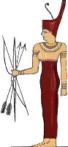
3.3.1 His Egyptian name
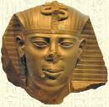
Figure 12 : Head and cartouche of pharaoh Amasis (II)
Figure 13 : Goddess Neith of Sais

His name in hieroglyphs is “Iâhmes sa Neith” meaning : “The one generated by Iâh” (the Egyptian moon god associated to Thoth in Hermopolis Magna), “the son of Neith” (the dynastic goddess of the 26th dynasty in Saïs, Athena for Greeks) ( Fig. 12 and 13).
Indeed he had the same name than the first king of the 18th dynasty in Thebes Iâhmes (I) Neb-pehti-ra (Ahmosis) whose mother was the great queen Iâh-hotep and the father king Se-qen-en-re of the 17th dynasty. The choice of the name of her son by the mother of Amasis (II) thus appeared to be perhaps justified by a claim for such ancestors.
3.3.2. Amasis’ family
Amasis was born in Per-Seped (Faqus) quarter of Nebeset, actual Saft-el-Hannah east of the delta, which has been the Hyksos territory, Goshen in the Bible. He was not a noble: his father Taperu was a commoner, but the name of his mother Ta-sheren-iset “the daughter of Isis » (Ranke, 1935; De Meulenaere, 1968) may indicate a relationship with the offspring of queen Iâh-hotep the mother of Ahmosis (I), who was lately assimilated to goddess Isis. This would not be surprising for a woman born in the eastern delta as well as the Ramses some six centuries earlier. The name of his maternal grandmother Tjenmutetj recalls the name of the mother of queen Teti-sheri, the grand-grandmother of king Ahmose (I) who was an “Asiatic” commoner named Tjenna.
King Amasis had three wiwes : the names of two ones were found in monuments : Tanetkheta and Chedebnejerbone, a daughter of his predecessor Apries. The third one, the Greek Laodice is only mentioned by Herodotus (II, 181) as a daughter of the Libyan king Battos (II) of Cyrene. Amasis made one of his daughters Nitocris (II) adopted as Great Spouse of god Amun in Thebes in order to strengthen his power on Upper Egypt.
3.3.3. Amasis’ carrier
After participating in the Nubian campaign of Psametik II, Amasis have continued his military carrier as general in the Egyptian armies under the reign of Apries, son of Psametik II. But a revolt which broke out among native Egyptian soldiers gave him his opportunity to seize the throne. These Egyptian troops, returning home from a disastrous military expedition to Cyrene in Libya, suspected that they had been betrayed in order that Apries, the reigning king, might rule more absolutely by means of his Greek mercenaries. Indeed, at that time many Egyptians were jealous about the treatment of favour given by Apries to his Greek soldiers. But general Amasis, sent to quell the revolt, was proclaimed king by the rebels instead, and Apries, who had now to rely entirely on his mercenaries, was defeated. Apries was either taken prisoner in the ensuing conflict at Memphis before being eventually strangled and buried in his ancestral tomb at Sais, or fled to the Babylonians and was killed mounting an invasion of his native homeland in 567 BC with the aid of a Babylonian army. An inscription confirms the struggle between the native Egyptian and the foreign soldiery, and proves that Apries was killed and honourably buried in the third year of Amasis (c. 567 B.C).
Amasis ostensibly conducted a foreign policy radically anti-Babylonians (Edel, 1978). On the death of Nebuchadnezzar II, he regained the Near East, and even invaded Cyprus. It is therefore the first and only time before the Ptolemies that Cyprus belonged to the Egyptian pharaoh. At that time Amasis was the undisputed master of Egypt, from the frontier with Nubia to Byblos in the Middle East and Cyprus, at least until 545 B.C. : at that time the Saïte revival was at its floruit, as Amasis have succeeded to raise Egypt to the level almost of what it was in the New Kingdom, coming from little and in a very unfavourable context.
But after that he had to counter the Persian hegemony. For that he made alliances formalized in a treaty between Babylon, Egypt, and Croesus the king of Lydia. Despite his efforts and his network of alliances, even with the old Babylonian rival, he could not stop the Persian expansion and all his supports gradually disappeared, starting with Croesus defeated by Cyrus the king of the Persians, and finally Babylon. A few months before the death of Amasis, Egyptians lost a battle against the Persians in 526 B.C., and a year later happened the final and fatal blow suffered by his successor, his own son Psametik III.
3.3.4 The philhellene pharaoh
Pharaoh Amasis reigned for forty-five years. He was immensely popular with his subjects, and established friendly relations with a number of Greek states, earning him the title Philhellene or "Greek-loving" (Cook, 1937; Grimal, 1988b). In fact, most historians agree that Amasis was put on the throne as the nominee of a fervid nationalist party ; that about 565 B.C., to please this party, he concentrated the Greeks in Naucratis, reorganised, if not founded, at this time, and only permitted them access to Egypt by the Canopic branch of the Nile; that at the same time he brought to Memphis from Stratopeda, usually equated with Daphnae and Tell Defenneh, the Greek and Carian mercenaries, either to have them more securely under control or by latent philhellenism. Later, he began more openly to favour the Greeks, making them his bodyguards, which attests to the high regard in which he held them. Having married the Greek princess Laodice of Cyrene, he contributed toward the reconstruction of the temple of Apollo at Delphi after its destruction by fire in 548 B.C. and made sumptuous gifts to the temple of Athena of Cyrene, Athena of Lindos in Rhodes, and to Hera of Samos. Moreover being fond of oracles, he had built a new temple for god Amun in the Siwa oasis in the north-western desert of Egypt (Herodotus, II, 176-182).
Amasis is deemed to have invited to his court great thinkers, philosophers and mathematicians such as the Greek Thales of Miletus and Pythagoras. Plutarch (The Banquet of the Seven Wises, 147a) insists on the admiration of king Amasis of Egypt seeing how Thales measured the height of a pyramid. One can interpret the astonishment of the king as the introduction of an entirely new method that surpasses the somewhat embryonic and empirical science of Egyptians (Baccou, 1951).
The king died in 526 BC and was buried at the royal necropolis of Sais. He was succeeded by his son Psametik III who reigned only one year being finally overthrown by the Persians invasion led by Cambyses. In Table I the historical events leading to Solon’s visit are chronologically listed :

Table I : Chronology of the events (in years B.C.)
______________________________________________________
Psametik I’s reign 664 – 610
Life of Solon 638 – 558
Necho II’s reign 610 – 595
Psametik II’s reign 594 – 589
Campaign in Nubia with Greek mercenaries 593 – 591
Apries’ reign 589 – 570
Amasis’ reign 571 – 526
Meroe becomes the royal residence of Kush circa 568
Visit of Solon in Saïs circa 561
Life of Hecateus of Miletus 550 – 480
Life of Herodotus 482 – 425
Life of Plato 427 – 348
______________________________________________________
4. CONCLUSIONS
When Solon came to Saïs circa 561 B.C. Egypt was already facing the threat of Persians, and Amasis had wanted to obtain a new military alliance with Aegeans. This could be the reason why the Sais priests wished to emphasize the ancient family relationship of the inhabitants of Sais with Athenians and magnified the military exploits of Greek mercenaries in the campaign of Psametik II against Kush, the millenary enemy of Egypt.
ACKNOWLEDGMENTS
I am indebted to Professor Stavros Papamarinopoulos for having warmly encouraged me to develop this part of my demonstration.

I thank Mr. George Sarantitis for his patient technical help in drawing maps.
REFERENCES
Baccou, R. (1951) Histoire de la science grecque de Thalès à Socrate, 1951, Paris: Aubier.
Bernand, A. and Masson, O. (1957) Les inscriptions grecques d'Abou Simbel. Revue des Etudes Grecques 70, 1-46.
Bonnet, C. and Valbelle, D (2005) L'expédition militaire de Psammétique II. In: Bonnet, C. and Valbelle, D., (Eds.) Des pharaons venus d'Afrique - La cachette de Kerma,. Paris : Citadelles & Mazenod. pp. 164-170.
Capart, J. (1940) Enquêtes. Potasimto. Chronique d'Egypte 29, 116-117.
Cook R.M. (1937) Amasis and the Greeks in Egypt. The Journal of Hellenic Studies 57, 227-237.
http://www.jstor.org/pss/627147
De Meulenaere, H. (1956) Trois personnages saïtes. 1. Le père de Potasimto. Chronique d'Egypte 31, 249-251.
De Meulenaere, H. (1968) La famille du roi Amasis. The Journal of Egyptian Archaeology 54, 183-187.
Der Manuelian, P. (1984) Living in the Past : Studies in Archaism in the Egyptian Twenty-Sixth Dynasty, 1984, London: Kegan Paul International. pp. 337-371, pl. 4-8.
Dillon, M.P.J. (1997) A Homeric pun from Abu Simbel (Meiggs and Lewis 7A). Zeitschrift für Papyrologie und Epigraphik 118, 128-130.
Edel, E. (1978) Amasis und Nebukadrezar II. Gottinger Miszellen Gottingen 29, 13-20.
Goedicke, H. (1981) The Campaign of Psammetik II against Nubia. Mitteilungen des Deutschen Archäologischen Instituts, Abteilung Kairo Mainz (Festschrift für Labib Habachi) 37, 187-198.
Grimal, N. (1988a) Éthiopiens et Saïtes. In: Grimal, N., Histoire de l'Egypte Ancienne, Paris: Fayard.
Grimal, N. (1988b) La présence grecque . In: Grimal, N., Histoire de l'Egypte Ancienne, Paris: Fayard.
Herodotus (5th c. B.C.) Histories, II, § 176-182. http://touregypt.net/herodotusonamasis.ht
Kendall, T. (2002) Napatan Temples: A Case Study from Gebel Barkal. Gebel Barkal, the Mythological Nubian Origin of Egyptian Kingship, and the Formation of the Napatan State. XI. Kingship Regained, Lost, and Reconceived - with Comments on the Nubian Campaign of Psammeticus II. pp. 67-70. http://wysinger.homestead.com/kendall.doc
Lefebvre, G. (1925) Пοτασιμτω (le général Pedi-sema-taoui, commandant des mercenaires de Psammétique II). Bulletin de la Société Archéologique d'Alexandrie 21, 48-57.
Lepsius, K.R. (1850-1973) Denkmäler aus Ägypten und Äthiopien, 1850-1973, Genève: Les Belles Lettres, Vol. VI, pl. 99, n° 531.
Luce, J.V. (1978) The sources and literary form of Plato's Atlantis narrative. In: Ramage, E.S., and (Ed.) Atlantis : Fact of fiction ?, Bloomington, Ind. USA: Indiana University Press, pp. 49-78.
Ranke, H. (1935-1977) Die Ägyptische Personennamen, 1935-1977 , Glückstadt: J.J. Augustin.
Ratié, S. (1962) Un « Chaouabti » du général Potasimto au musée d'Annecy [avec 5 planches]. BIFAO 61, 43-53.
Rowe, A. (1938) New lights on objects belonging to generals Potasimto and Amasis. Annales du Service des Antiquités de l'Egypte (ASAE) 38, 157-195.
Sartre, M. (2009) Graffiti on Ramses II's leg or Greek mercenaries and merchants in pharaonic Egypt. In: Sartre, M. and Porter, C. Histoires grecques : Snapshots from Antiquity,. Cambridge, Mass. : Harvard University Press pp. 35-45. http://books.google.fr/books?id=OsZnSt5IoEcC&pg=PA35&lpg=PA35&dq=Graffiti+d%27Abu+Simbel&source=bl&ots=NQeO2QtPVN&sig=Ci7AiV2KpaX74mSMXmvgL3Uougs&hl=fr&ei=4S50StTQF83RjAem5OGnBg&sa=X&oi=book_result&ct=result&resnum=9#v=onepage&q=&f=false
Sauneron, S. and Yoyotte, J. (1952) La campagne nubienne de Psammétique II et sa signification historique. Bulletin de l'Institut Français d'Archéologie Orientale (BIFAO) 50, 157-207.
Taylor, I. (1883) The alphabet : an account of the origin and development of letters, 1883, London: The Royal Society of Literature. Vol. 1, pp. 201-202. http://books.google.fr/books?id=WIN3-1k9Q7IC&pg=PP2&dq=taylor+isaac+thealphabet+Book+Il&source=gbs_selected_pages&cad=3#v=onepage&q=&f=false
Török, L. (1997) The campaign of Psamtik II against Kush in 593 B.C. In: Török, L., (Ed.) The kingdom of Kush. Handbook of the Napatan Meroitic civilization, Leiden: Brill. pp. 360-362, 371-374.
http://books.google.fr/books?id=i54rPFeGKewC&printsec=frontcover&source=gbs_v2_summary_r&cad=0#v=onepage&q=&f=false
Westman, P. (1990) The New Papyrological Primer, 2 edn. 1990, Brill. p. 7. http://books.google.fr/books?id=96I3AAAAIAAJ&dq=The+New+Papyrological+Primer+by+P.+W.+Pestman&printsec=frontcover&source=bl&ots=Pe5_YQcTEV&sig=GIP8MDLJ4dx6M_L8-IzJfiAXFZs&hl=fr&ei=mhSBSuf6NNmMjAeAmMX0CQ&sa=X&oi=book_result&ct=result&resnum=1#v=onepage&q=&f=false
Yoyotte, J. (1953) Potasimto de Pharbaïthos et le titre "grand combattant - maître du triomphe". Chronique d'Egypte 54, 101-106.

