Atlas the Titan and the two “bearer” kings of Kush
Part II : Kamose as Thuthmose I, the first Egyptian ruler of Kush
Th. Ghembaza
Independent researcher, France

ABSTRACT
During the Second Intermediate Period, the Theban armies had to fight against the Kushite ruler of Kerma who was allied to the Hyksos occupants of Lower Egypt. King Kamose started the war to regain Lower Egypt and finally took Avaris, the Hyksos capital city. But when his half-brother Ahmose claimed the sovereignty on the whole land of Egypt, Kamose refused to render him the Lower Egypt he had recovered “by the strength of his arms”. He closed himself with his supporters and mercenaries in the fortress of Avaris and Ahmose decided to besiege his half brother with the Theban army. Thanks to their mother Queen Ahhotep, an agreement was concluded between the two adversaries, but Kamose was obliged to keep out of Egypt for forty years, as for state reason he was pronounced dead fighting the Hyksos enemy. During his long exile, he could govern Nubia and walked through all the inhabited Asia as far as India and East Africa where he made colonies whose tributes enriched Egypt.
Forty years later when King Amenophis I, Kamose’s grandson by Queen Ahmose-nefertari, was dead without male heir, unexpectedly an old general come from Nubia ascended the Theban throne without difficulty. He claimed that his mother was the great King’s mother Seniseneb, but his father remained unknown. Considering he had the agreement of the Mother-queen Ahmose-nefertari, probable eldest daughter of Kamose with a Kushite princess of Meroe, we intend to demonstrate that Thuthmose I was old Kamose fulfilling his royal destiny at 67 years of age.
- INTRODUCTION
The Kushite pharaohs of the 25th Dynasty reigning in Egypt always claimed to be the heirs of their ancient Egyptian rulers. It is a fact that King Kamose of the 17th Dynasty had already to fight against the powerful kingdom of Kerma in order to impede the Kushite armies to ally with the Hyksos occupants of Lower Egypt. Consequently, as early as the reign of his successor Ahmose, the Land of Kush began to be ruled by viceroys vassal of Egypt. The first one of a long series of these so-called “King’s son of Kush” was named Djehuti (Toth) under the reign of King Ahmose, and forty years later, he could be appealed to reign in Thebes under the throne name of Thuthmose I. By the fact it is now necessary to know what was the real course of Kamose’s life.
2. Kamose : a badly known THEBAN hero
2.1. The Hyksos : Asiatic kings reigning on Lower Egypt
At the beginning of the so-called Second Intermediate Period (ca.1650-1550 B.C.), Lower Egypt was invaded by foreign Asiatic people who named themselves “heqa khaswt” meaning “prince of the mountainous lands”, while the Egyptian historian Manetho called them “Shepherds kings” and Flavius Josephus (Contra Apionem I, 14) “Hyksos”. As these ferocious warriors were heavily armed, they rapidly defeated the Egyptian soldiers, so that the Theban king, probably Antef (VII) Nubkheperre preferred to flee in a hurry to Lower Nubia whose ruler was a friend of him (Fl. Josephus, C.A. I, 32 ). (As we will see, Antef VII was the last purely Egyptian pharaoh until the 26th Dynasty appeared in Sais eight centuries later). After him, a new king named Seqenenre Tao ascended the Theban throne. His wife was queen Ahhotep. Archaeological data tell us that they were brother and sister, both children of the great Mother queen Teti-sheri, but without mentioning the name of his husband. In fact, there are indices that these new sovereigns were near relatives of Oqenenere Apophis, the Hyksos king ruling Lower Egypt from his capital Avaris, east of the delta (15th Dynasty). As Eusebius (49, from book II of Manetho) said: “Kings of the 17th Dynasty: They were Shepherds, Phoenician brothers, foreign kings who captured Memphis”.
But some years later, King Seqenenere was savagely murdered on behalf of the Hyksos king, probably his own brother, who intended to rule the whole Egypt. At that time, the son of the murdered king, Ahmose was still a child. So Queen Ahhotep became regent and she appealed to her eldest son Kamose to act as general in chief of the Theban army. Although very young (16 or 18 years old), this warrior prince was a key figure in the recovering of Lower Egypt occupied for one century by Hyksos (ca. 1650-1550 BC) (Fig. 1)
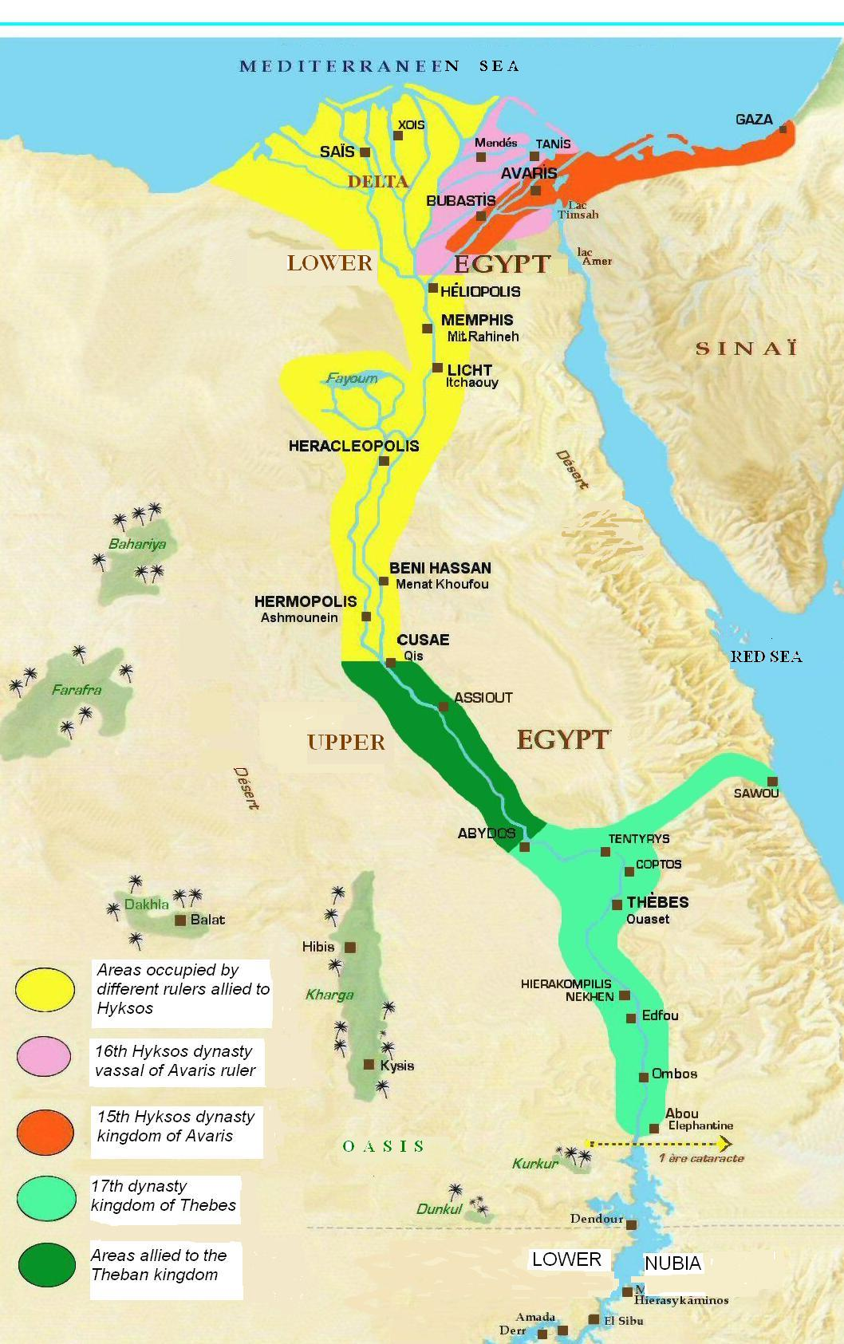

Figure 1. The divisions of Egypt during the Hyksos occupation:
- - From the delta to Middle Egypt (Cusae) : the area controlled by Asiatics (15th and 16th dynasties)
- From Cusae to Aswan : the area under the control of the Theban pharaoh (17th Dynasty).

.
2.2. A long war of recovery against the Asiatic occupants
Kamose himself left us three testimonials of his military exploits engraved on two steles and a tablet found in Karnak. According to these texts, he had to fight firstly against Nubians (Kushites) who were allied to Hyksos, and then he took the Hyksos capital, the fortress of Avaris. Kamose gave us the report of the situation of Egypt at that time on his stele dated on the 3rd year of his reign [Lacau, 1939; Redford, 1997].
“His Majesty spoke in his palace to his council of magistrates who were in his train: 'To what end do I know my (own) strength? One chief is in Avaris, another in Kush, and I sit (here) associated with an Asiatic and a Nubian! Each man has his slice in this Egypt and so the land is partitioned with me! None can pass through it as far as Memphis (although it is) Egyptian water! See he (Apophis) has even Hermopolis ! No one can be at ease when he is milked by the taxes of the Asiatics. I shall grapple with him that I might crush his belly, (for) my desire is to rescue Egypt which the Asiatics have destroyed’.
Then spoke the magistrates of his council: ‘See, as far as Kos it is Asiatic water, and they have drawn out their tongues of one accord. We are doing all right with our (part of) Egypt: Elephantine is strong, and the interior is with us as far as Kos. Their free land is cultivated for us, and our cattle graze in the Delta fens, while corn is sent for our pigs. Our cattle have not been seized, and have not been tasted. He (Apopi) has the land of the Asiatics, we have Egypt. Only when comes one who acts against us should we act against him.’ But they troubled His Majesty's heart. ‘As for your counsel it is opposite me. He who partitions the land with me will never respect me... I will sail north to engage the Asiatics and success will come! The Mighty Ruler in Thebes, Kamose the Strong, protector of Egypt.”
Then, Kamose understood that the best defence was attack as attested by his discourse addressed to Apophis Owserre in his second stele [Habachi, 1972]: “Bad news is in your town: you are driven back in the presence of your army, and your authority is restricted. In as much as you, in your capacity as suzerain, have made me a chief - so that (now) you must (even) beg for the block where you shall fall. Look behind you! My troops are a threat behind you. The mistresses of Avaris shall not conceive, their hearts shall not budge in the midst of their bodies, when the war-whoop of my troops is heard! I put in at Per-djedken, my heart happy, so that I might let Apopi experience a bad time, that Syrian prince with weak arms, who conceives brave things which never come about for him! I arrived at Yenyet of-the-southward-journey, and I crossed over to them to greet them. I put the fleet (already) equipped in order, one behind the other, in order that I might take the lead, setting the course, with my braves, flying over the river as does a falcon, my flag-ship of gold at their head, something like a divine being at their front. I made the might transport boat beach at the edge of the cultivation, with the fleet behind it, as the sparrow-hawk uproots (plants) upon the flats of Avaris !... Behold! I am come, a successful man! What remains is in my possession, and my venture prospers! As mighty Amun endures, I shall not leave you, I shall not allow you to tread the fields even when I am not (here) with you! Does your heart fail, O you vile Asiatic? Look! I drink of the wine of your vineyards, which the Asiatics whom I captured pressed out for me. I have smashed up your rest house, I have cut down your trees, I have forced your women into ships' holds. I have seized [your] horses; I haven't left a plank to the hundreds of ships of fresh cedar which were filled with gold, lapis, silver, turquoise, bronze axes without number, over and above the moringa-oil, incense, fat, honey, willow, box-wood, sticks and all their fine woods - all the fine products of Retenu - I have confiscated all of it! I have not left a thing to Avaris to her (own) destitution: the Asiatic has perished! Does your heart fail, O you vile Asiatic, you who used to say: 'I am lord without equal from Hermopolis to Pi-Hathor upon the Rekhty water. (As for) Avaris on the Two Rivers, I laid it waste without inhabitants; I destroyed their towns and burned their homes to reddened ruin-heaps forever, because of the destruction they had wrought in the midst of Egypt: they, who had allowed themselves to hearken to the call of the Asiatics, had forsaken Egypt their mistress!”
However, we have no other data about Kamose after the third year of his campaigns. So, most of archaeologists think he died in battle shortly after. Moreover, not any information was found concerning his kinship with the previous reigning families. However, his name appears in several dynastic lists between those of King Seqenenre Tao of the 17th Dynasty and King Ahmose, first king of the 18th Dynasty. Kamose’s tomb was a pyramid still existing under the reign of Ramses IX, but his coffin was found by Mariette in 1859 on a pile of rubble in the valley of Dra abul Naga near Thebes. Unfortunately, the mummy had fallen to dust at the opening. However, the coffin had not been robbed as it contained several weapons of precious metals, which are magnificent pieces of jewellery with royal cartouches [Winlock, 1924].

3. AN ATTEMPT OF RECONSTRUCTION OF KAMOSE’S BIOGRAPHY
It is a fact that we have no proof in Egyptian records that Kamose was alive after his third year of rule, but there is also no proof that he died at that time. A French archaeologist, Christophe Barbotin allows him eleven years of reign [Barbotin, 2008]. As for us, we want to claim that Kamose had an adventurous and fruitful life and died around 80 of age. Basing on literary traditions, we will propose the following reconstruction of the biography of this historical figure of exceptional dimensions.
3.1. Epaphos the bastard of the Moon
Several literary traditions could reflect the events of the life course of Prince Kamose “the bull’s son” which is the meaning of his birth name. According to the tale of princess Io, priestess of the Moon in Argos, who gave birth to a bull in Egypt (Apollodorus, Library, II, 1,3), Kamose could not be really Egyptian, nor Greek, but from Asiatic origin (Middle East). The Greek tale gave Zeus as father of the bull Epaphos, but considering the tale of Adonis honoured in Byblos with his mother Aphrodite, the young princess could be raped by her own father designated as Kinyras king of Cyprus, Theias king of Syria or Belos king of Egypt. According to the legend of Atrids the young princess had not recognized her rapist but she took his sword (Apollodorus, Epitome, II, 14 ; Hyginus, Fabulae, 86-88). When she became pregnant, the old king wanted to kill her in order to avoid to be dethroned by his grandson as an oracle had predicted to him. For this reason, the princess fled to Egypt where she was welcomed by the pharaoh and his queen (Fig. 2). As she was a priestess of the Moon, she received the Egyptian name of Ahhotep “the one who honours the god Ah (or Iâh)” the Moon, an Asiatic deity associated with the Egyptian god Thoth. But at that time, an Asiatic ruler, King Apophis Oqenenre reigned on the East of Lower Egypt and he could be an elder brother of princess Io (Ahhotep).
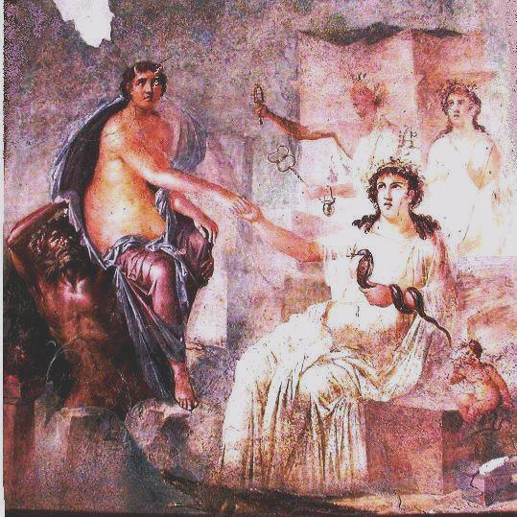

Figure 2. Princess Io with cow horns welcomed in Egypt by Isis (Roman fresco of Pompei, Italy)

Considering the circumstances of the birth of Kamose, we can also remember the legend of the birth of Sargon I king of Akkad : “My mother was a great priestess. My father I do not know him. My father’s uncles encamped in mountains”. Moreover, the name Sargon in Akkadian language is “Sharru-kin” (the rightful king) which is the same name as the Hyksos fortress south of Canaan named Sharruken in Egyptian language. In fact, we have no archaeological proof of the life of Sargon first king of Akkad, and his dating is probably very much too high, taking in account the imprecision of the excavations made in the 19th century in Mesopotamia. Therefore, there could be a relationship between the mythic king of Akkad and Kamose, the bull son of Io, priestess of the Moon.
3.2. A youth in Nubia
Although the princess of Argos was already pregnant when arriving in Egypt, probably she omitted to tell the truth to the pharaoh. That allowed her to say she gave birth to a royal child prematurely. Indeed, when the princess was on the time to bear her baby, the Hyksos beat the Theban army. At this time Pharaoh Antef VII was obliged to flee in a hurry to the court of a Nubian ruler who was his friend (probably in Napata). Unable to make the travel, Ahhotep had to hide to give birth to Kamose, as the Hyksos ruler looked for the baby to kill him. In order to save her grandson, his own grandmother queen Teti-sheri (Leto), although menopausal, said he was her own baby and nursed him until he was 5 years-old. At this time, the exiled pharaoh Antef VII remained without heir, took the child as his son and reared him in Nubia in order to make him a warrior-prince able to recover his Egyptian kingdom from Hyksos.
All these data are given to us by ancient authors:
- Herodotus, II, 146 : “With regard to Dionysos the Hellenes say that as soon as he was born Zeus sewed him up in his thigh, μηρό (mero) in greek, and carried him to Nysa (Meroe), which is above Egypt in the land of Ethiopia (Kush present North Sudan)”.
- Plutarch, De Iside, 35 : “Many of the Greeks make statues of Dionysos Tauromorphos” (Bacchus in the form of a bull).
- Flavius Josephus, Contra Apionem, I, 32, 292: “That Amenophis (Antef VII confounded with Amenophis I for the reason why we will explain further) could not sustain their attacks, but fled into Ethiopia (Nubia), and left his wife with child behind him, who lay concealed in certain caverns. And there she brought forth a son, whose name was Messenez, and who, when he was grown up to man's estate, pursued the Jews into Syria, being about two hundred thousand, and then received his father Amenophis out of Ethiopia."
3.3. The war of Zeus (of Nysa) against the Titans, Hyksos in Egypt
Indeed Kamose could be abandoned at birth by his mother and remained persuaded for a long time that he was a genuine Egyptian. Being reared in Nubia, he had been 16-18 years old when returning to Egypt. According to an Egyptian tradition he wanted to meet his mother. Herodotus (II, 63) reported: “At Papremis …the mother of Ares, they say, used to dwell in this temple, and Ares, having been brought up away from her, when he grew up came thither desiring to visit his mother. And the attendants of his mother's temple, not having seen him before, did not permit him to pass in, but kept him away. Thus, he brought men to help him from another city and handled roughly the attendants of the temple, and entered to visit his mother.”
After the adoption of her child by King Antef VII in Nubia, Kamose’s mother had married her own brother and both reigned in Thebes under the names of King Seqenenere Tao and Queen Ahhotep. So Diodorus (III, 71) said : “When the valour and fame of Dionysus (Kamose) became spread abroad, Rhea (Ahhotep) angered at Ammon (Antef VII), strongly desiring to get Dionysus into her power. However, being unable to carry out her design, she forsook Ammon and, departing to her brothers, the Titans (Hyksos), married Cronus (Seqenenre Tao) her brother. Cronus, then, upon the solicitation of Rhea, made war with the aid of the Titans upon Ammon, and in the pitched battle which followed, Cronus gained the upper hand, whereas Ammon, who was hard pressed by lack of supplies, fled to Crete. And marrying there Crete, the daughter of one of the Curetes (of Kurru) who were the kings (of Nubia) at that time, gained the sovereignty over those regions.”
“As for Cronus, the myth relates, after his victory he ruled harshly over these regions which had formerly been Ammon's, and set out with a great force against Nysa and Dionysus… But Dionysus gathered a great army with Libyans (Africans) and Amazons (Touareg Amazighen) and was victorious against Cronos and the Titans. Having gathered many captives he offered them to join his armies. Then he captured Cronos and Rhea but he considered them as his parents all the rest of their life. Rhea loved him like a son (as he was really), but the good-will of Cronos was a pretence.” So, perhaps King Seqenenre was murdered in an ambush he had himself laid to Kamose who killed him in self defense (Ginzberg, 1909).
3.4. The rebellion and exile
When King Seqenenere was dead, his elder son Senakhtenre Ahmose reigned only one year and died. At that time, the kingdom of Thebes was deeply weakened facing the threat of the Hyksos king of Avaris who planned to reign on the whole land. Therefore, the widowed queen appealed to Kamose to rule as regent of her youngest son Ahmose still a child. Kamose decided the best defence was attack [Gardiner, 1916]. As reported by Flavius Josephus (C.A. Bk I, 14: 86-87 and 27: 251), after a long war of recovery Kamose took Avaris the Hyksos capital [Lacau, 1939 ; Habachi, 1972].
Now, Egyptologists refuse to believe that Kamose really succeeded in seizing Avaris. Basing on the imprecision of Egyptian conjugations, they say it was only his project. In fact, they did not understand why the city of Avaris was besieged for a second time by king Ahmose ten years later. The reason was that Kamose had refused to render the power to his half brother Ahmose having reached the age to reign. He intended to continue to rule Lower Egypt he had recovered “by the strength of his arms”. So Kamose had become a rebel retreated in Avaris with his devoted soldiers and Ahmose has decided to besiege Avaris with the Theban army to quell the rebellion.
Curiously, this second siege lasted only some months. But according to Flavius Josephus (C.A. I, 88) ; "The Shepherds built a wall round all this place, which was a large and a strong wall, and this in order to keep all their possessions and their prey within a place of strength. But that Thummosis (Ahmose) the son of Misphragmuthosis (Kamose who has ruled before him) made an attempt to take them by force and by siege, with four hundred and eighty thousand men around them. But, upon his despair of taking the place by that siege, he came to a composition with them, which they should leave Egypt, and go, without any harm to be done to them, whithersoever they would. And after this agreement was made, they went away with their whole families and effects, not fewer in number than two hundred and forty thousand, and took their journey from Egypt, through the wilderness, for Syria. But as they were in fear of the Assyrians, who had then the dominion over Asia, they built a city in that country which is now called Judea, and that large enough to contain this great number of men, and called it Jerusalem”.
Here it appears that Ahmose renouncing to the siege concluded an agreement with Kamose to let him go out of Egypt with all his partisans. In fact, there is an archaeological testimony, which let us suppose that queen Ahhotep had managed to obtain an arrangement between her two sons (Kamose the eldest one and Ahmose the youngest). Indeed a stele was found in Karnak [Lacau, 1957] where King Ahmose honoured his mother for her beneficent actions for Egypt: “She is the one who accomplished the rites and took of Egypt which before protected her. She looked after her soldiers, she brought back her fugitives and collected together her deserters, she pacified Upper Egypt and expelled her rebels”. In fact, she had supported the accession of Ahmose to the Theban throne in order to keep in her hands the supreme power, as her youngest son Ahmose was a rather weak and frail person, whereas Kamose her eldest son was strong and autocratic. According to this treaty of peace, Ahmose inherited of the Egyptian kingdom and married Ahmose-Nefertari the mongrel daughter of Kamose with a Nubian princess of Meroe (Fl. Josephus. Antiquity of the Jews, II, 10). As a counterpart, Kamose married Ahmes Merit-Amun a sister of Ahmose and inherited the Land of Canaan and Syria, the land of his Asiatic ancestors.
But according to Pseudo-Manetho (Fr3, 46-47) “King Armaios (Ahmose) also called Danaos reigned only nine years on Egypt. Then fleeing his brother Rhamesses (Kamose) also called Egyptos, he emigrated to Greece”. See also the Greek tale of Athamas (Apollodore, Library I, 7, 3 ; I, 9, 1-2 ; III, 4, 2-3).
3.5. Pharaoh Thuthmose I : an old general come from Nubia
Finally defeated by the Theban army of King Ahmose, Kamose and the people of Avaris were obliged to leave Egypt. The Asiatics returned to their homeland in Asia Minor, but Kamose quitted them when arriving in front of Canaan. Then, he continued to explore the Asian and African world travelling by land and by sea (Diodorus, I, 53), so giving birth to the legend of the Wandering Jew. Firstly, during the reign of Ahmose, Kamose could reign in Nubia as a viceroy under the name of Djehuti (a form of Thoth).
But forty years later, when Amenhotep I, the grandson of Kamose by his daughter Ahmose-Nefertari, died without male heir, the Theban throne became vacant. At that time an old general come from Nubia ascended the throne under the reign name of Thuthmose I (son of god Thoth = Ah the Moon). The newcomer was already an old man. He hastened to claim to Nubia officials that his coronation in Thebes happened without problem [Bonheme, 1978]. He said that his mother was the great King’s mother Seniseneb, but without any information concerning his father and grandparents. We know that there were some queens Senebsen from the 13rd to the 17th Dynasty [Vandersleyen, 1995], but their husbands are unknown. We can only propose the supposed mother of Thuthmose I could be in fact Queen Teti-sheri Kamose’s grandmother of who hid him as baby in Khemnis island where papyrus seneb was growing. By this way, the new king Thuthmose I intended to appear as the direct heir of the last Egyptian rulers of the 17th Dynasty (Figure 3).
During his short reign of thirteen years, Thuthmose I had to quell two local revolts of Kushite rulers and he reached Kurgus beyond the Fifth Cataract in Nubia. Moreover, he brought to Egypt a sense of stability, and his successful military campaigns healed the wounds of Theban people. We learn from his Abydos stele about his building works at Thebes. His architect, Ineni, built an extension to the temple of Amun at Karnak, adding pylons (the fourth and fifth), courts, statues and one of the Egypt largest standing obelisks. To commemorate his victories he built a hypostyle hall made entirely of cedar wood columns. He also expanded "the Treasury" begun by his predecessor at the northeast corner of the complex. The Abydos stele tells us that Thuthmose I made also contributions to the temple of Osiris, including cult objects and statues. Further, he apparently did some substantial work at Giza. In fact, he was responsible for a number of building projects within Egypt proper, where he left indications of structures at Elephantine, Armant, Ombos (near the late 17th to early 18th Dynasty palace center at Deir el-Ballas), el-Hiba, Memphis and probably at Edfu.
There are also a number of monuments in Upper and Lower Nubia left by Thuthmose I and his viceroy, Turi. On the site of Kerma-Doukki Gel the Swiss archaeologist Charles Bonnet unearthed the foundations of several temples and palaces built by Thuthmose I when he conquered the Kushite capital city, which were maintained by his successors Hatshepsout and Thuthmose III in the early 18th Dynasty.
We believe that there are several structures that may date from his reign near Kenisa at the Fourth Cataract and at Napata. Traces of ruins also exist at Semna, Buhen, Aniba, Quban and Qsar Ibrim, though most of these were probably small, or additions to earlier buildings. We also find a few votive objects dedicated in his name in the Sinai at the temple of Serabit el-Khadim.
Thuthmose I died when he was about eighty. His mummy was not found although two subterranean tombs seem to have been successively prepared for him in the Valley of the Kings [Reeves, 1990]. But according to different late traditions mainly pertaining to the mythic Sesostris-Sesoosis (Herodotus II, 102-11, Diodorus I, 58:3), living very old the king became blind and committed suicide by losing himself in the Theban marshes where he was devoured by a hippopotamus. (This king was designated as Menes by Manetho I, 1). For this reason, the tombs and coffins intended for King Thuthmose I could never been used for him.
3.6. Thuthmose I as old Kamose fulfilling his royal destiny
If Kamose was still alive in the beginning of the reign of Thuthmose I, he could be about 67 years-old and many of the people who knew him before his departure out of Egypt were already dead. When forty years before he rebelled against the Theban power, Kamose became a traitor and according to the Egyptian law, he should be punished by death. So in order to save his eldest son, Queen Ahhotep could claim he died in battle and organized false funerals with great pomp, putting in the royal coffin the calcinated body of a soldier dead in a feuer. Indeed, the intact coffin of Kamose was found in Dra abul Naga [Winlock, 1924] but at the opening, the corpse got into dust, as he had not been mummified. Consequently, we can wonder if the body was really King Kamose’s one or that of a commoner substituted to him for state reasons. (Fig. 4).
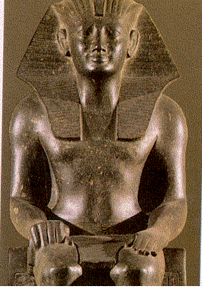
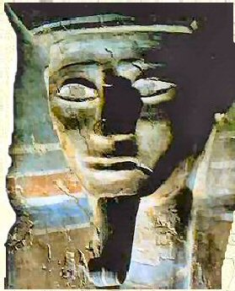

Figure 3: Pharaoh Thuthmose Ist (Berlin Museum). Was he old Kamose ?)
Figure 4: Portrait of young Kamose on his coffin lid.

In this view, there are several arguments more to think that Thuthmose I come from Nubia was old Kamose :
- We know that the accession of Thuthmose I to the Theban throne could not happen without the support of the Mother queen Ahmose Nefertari who was probably Kamose’s eldest daughter. Moreover, the king was very affected by the death of the Mother queen when she was about fifty-five years old [Edwards, 1965].
- He was the first Egyptian king to choose the name Thuthmose meaning “generated by Toth” which is the proper epithet inscribed on a dagger of Kamose with the same graphics: god Thoth as an ibis on its perch [Vandersleyen, 1995].
- The throne-name of Thuthmose I Okheperkare could explain why Kamose as Thuthmose I was called Sesostris by late authors who confounded him with king Sesostris (I) Kheperkare of the 12th Dynasty.
- Thuthmose I had a beloved son named Wadjmose, which recalls the reign name of Kamose Wadjkheperre (But this son died as a child).
- Moreover, it appears that Kamose could act as a regent for Amenophis I as soon as King Ahmose died. Indeed a military campaign was led in Nubia in the 8th year of Amenophis I’s reign when the king was only 13 years old.
- Thuthmose I’s wife was queen Ahmes perhaps a sister of Amenophis I. In this case, she could be the proper granddaughter of Thuthmose-Kamose by his eldest daughter Ahmose-Nefertari (the Mother queen widow of king Ahmose).
- And finally, Thuthmose I as well as Kamose was a great conqueror and builder, and both of them had a strong relationship with Nubia (the Land of Kush).
4. Kamose in literature, a proteiform character
Many data which are lacking to archaeologists can be found in literary traditions, although the events and names of the persons are often deformed by long centuries of oral reports and multiple compilations. Kamose, indeed, appeared under different names in ancient authors, but it is obvious that the deeds attributed to these different heroes are the same ones and pertain to the same Egyptian figure.
4.1. Sesostris a mysterious Egyptian king
Sesostris (named Sesoosis by Diodorus) is the Greek form of the Egyptian name Senousret : “the one pertaining to the Powerful (goddess of Thebes)”. Archaeologists consider that this mysterious character was a mixture of three historical persons: the Egyptian kings Sesostris I and Sesostris III of the 12th Dynasty, and Ramses II of the 19th Dynasty, because of their military campaigns in Asia and Nubia. Nevertheless, reading ancient authors, there are several reasons to recognize King Kamose Wadjkheperre himself in the mythic figure of King Sesostris, as we intend to demonstrate :
- Herodotus (II, 102-103 and 106-110) said that the only Egyptian king to have reigned on Ethiopia (Nubia) was the famous Sesostris who was a great warrior whose military equipment was partly Egyptian and partly Nubian.
- Diodorus (I, 53-59) described him as a powerful leader of men, distributing pieces of land to retain his supporters and freeing the prisoners for debt. Having assembled a powerful army and believing to become the master of the world, he conquered firstly Arabia and Ethiopia (North Sudan). He was the first king of Egypt to build war boats (Fig. 5) and pursued his conquest as far as India and globally his empire exceeded Alexander the Great’s one. (In fact, his itinerary corresponds also to the peregrinations of god Dionysos in Greek mythology and to the conquests of god Osiris in Egyptian tradition, as we will see further).
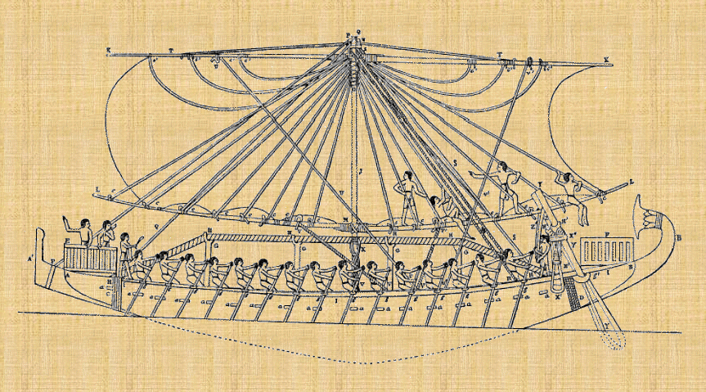

Figure 5. An Egyptian boat of war.

- And Diodorus (I, 53: 2-4) gives us this precision: “At the birth of Sesoosis (Sesostris) his father did a thing worthy of a great man and a king: he gathered together from over all Egypt the male children who were born on the same day. Then, assigning them nurses and guardians, he prescribed the same training and education for them all, on the theory that those who had been brought up in the closest companionship and had enjoyed the same frank relationship would be most loyal and the most brave fellow-combatants in the wars. He amply provided for their every need and then trained the youths by unremitting exercises and hardships: for no one of them was allowed to have anything to eat unless he had first run one hundred and eighty stades (20 km). Consequently, upon attaining to manhood they were all veritable athletes of robustness of body, and in spirit qualified for leadership and endurance because of the training which they have received in the most excellent pursuits.”
- And Strabo (XVI, 4:4) concerning the area of Bab-el-Mandeb Straits reported: “There is a pillar of Sesostris the Egyptian, which tells in hieroglyphics of his passage across the gulf; for manifestly he was the first man to subdue the countries of the Ethiopians and the Troglodytes. And he then crossed into Arabia, and thence invaded the whole of Asia ; and actually, for this reason, there are in many places palisades of Sesostris, as they are called, and reproductions of temples of Egyptian gods.”
- Finally according to Diodorus (I, 58), after reigning for thirty-three years, Sesostris become blind committed suicide by losing himself in Theban marshes where he was devoured by a hippopotamus.
4.2. Dionysus the Zeus of Nysa-Meroe
However, Kamose “the son of the bull” seems also appear again in the biography of other mythic figures if we consider them under a euhemerist perspective. So does the life of Bacchus-Dionysus, the Zeus of Nysa.
According to Herodotus (II, 146) “Dionysus sewn into the thigh of Zeus, was taken in Ethiopia”. And according to Plutarch (De Iside, 364e ) “In Argos Dionysus was called Bugenes (generated by a bull), what corresponds to the legend of Io of Argos got into a heifer by Zeus and giving birth to a bull in Egypt. Diodorus from Libyan (African) sources (Book III, 68-74) reported “Become adult Dionysus returned from Ethiopia (Kush) to Egypt and fought against the Titans to defend his father Ammon”.
It is obvious that the “first Dionysus”, the son of Ammon and Amaltheia and the “second Dionysus” born by Io and become king of Egypt were a unique person. And the “third Dionysus” of the Greek tradition, “who led an army over all the inhabited world and left behind him not a few pillars to mark the bounds of his campaign” resulted from the two previous ones : “And he selected women to be his soldiers as the ancient Dionysus had done in the case of the Amazons”. And Diodorus (III, 74) emphasized that everybody agrees that Dionysus fought on the side of Zeus (the pharaoh) in his war against Titans, as Kamose did fighting the Hyksos as regent of his half brother Ahmose still a child.
4.3. The Egyptian Heracles, the glory of Ahhotep
It same goes for the Egyptian Heracles as reported by Herodotus (II, 42-44) and Diodorus (III, 74): “For there had been two persons of an earlier period who had borne the same name, the most ancient Heracles who, according to the myths, had been born in Egypt, had subdued with arms a large part of the inhabited world, and had set up the pillar which is in Libya (Africa)”. This Heracles was Kamose and his mother was the queen of Egypt named Ahhotep “the one who honors Ah (the Moon god)”, which explains the Greek name Heracles “the glory of Hera” as the glory of his mother. Manetho himself named Arkhles the 5th Hyksos king of the 15th Dynasty with a reign of 49 years, followed by a king Apophis.
The second Heracles born by Alcmene was named Alcid at birth by the name of his Greek grandfather, but he obtained the nickname of his Egyptian ancestor because he accomplished many glorious deeds as his ancestor have done before him (Diodorus, I, 24).
4.4. The Greek-Egyptian syncretism
All these facts do explain why Eratosthenes of Cyrene in his Chronology of the Egyptian kings making a synthesis of three of these mythic characters could identify the 34th king of the Egyptian Thebes as “Sistosichermes valiant Heracles” alias Kamose confounded with King Sesostris (I) kheperkare of the 12th Dynasty. Indeed Eratosthenes was the curator of the Alexandrian Library in the IIIrd century B.C. and he had at his disposal all the books of the most ancient authors. Probably he had also access to the annals of the Egyptian temples, although these ones were written in hieratic script whereas the current Egyptian script was become the demotic. And according to Plutarch (De Iside 27) Mnaseas identified Bacchus, Osiris and Serapis as Epaphus.
It also necessary to explain why Kamose (Chermes) associated with Sesostris (Sistosi) was also identified as the Egyptian Heracles. Firstly, it is obvious that the deeds of the mythic Sesostris are similar to those of the Egyptian god Osiris. As according to Diodorus (I, 25) “Osiris was given the name Serapis by some, Dionysus by others, Pluto by others, Ammon by others, Zeus by some, and many considered Pan to be the same god; and some say that Sarapis is the god whom the Greeks call Pluto. And Plutarch (De Iside, 36) reported: “Apophis (the Hyksos King Oqenenre in Avaris), brother of the Sun (the old Hyksos king Owserre), declared the war to Zeus (Amun= Antef VII). Osiris (Seqenenre Tao) came to Zeus' help and helped him to put the enemy in discomfiture. Zeus (Antef VII) adopted then Osiris' son (Kamose) and called him Dionysos». Finally (Diodorus, Book I, 17) said : “After Osiris (Seqenenre) had established the affairs of Egypt, he turned the supreme power over to his spouse Isis (Queen Ah-hotep). He placed Hermes (the oracle of god Thot-Ah) at her side as counselor because his prudence raised him above the king's other friends. And as general of all the land under his sway he left Heracles (Kamose), who was both his kinsman and renowned for his valour and physical strength, while as governors he appointed Busiris (Oqenenre Apophis) over those parts of Egypt which lie towards Phoenicia and border upon the sea, and Antaeus (Antef VII) over those adjoining Ethiopia and Libya. Then he himself left Egypt with his army to make his campaign, taking in his company also his brother, whom the Greeks call Apollo. “
Moreover, according to another source (Diodorus I, 15), Osiris interested to agriculture was reared in Nysa, city of Arabia close to Egypt, being son of Zeus (Jupiter-Amun) and for that he was called Dionysos by Greeks who named him also Hermes. In addition, Diodorus (I, 17-20) reported: “Osiris made road through Ethiopia. He was received like a god because of his kindness. He took his road through Arabia until India. Egyptians tell that his two sons Anubis and Makedon accompanied Osiris on his campaigns. Anubis wore a skin of dog and Macedon the foreparts of a wolf. Macedon his son, moreover, he left as king of Macedonia, which was named after him, while to Triptolemus he assigned the care of agriculture in Attica” (Diodorus, Book I, 27, 5-6). Here it appears that Osiris is no more Seqenenre Tao but Kamose himself, previously considered as Osiris’son adopted by Zeus and named Dionysus. Moreover, according to Diodorus (I, 27: 3-6) “On the tomb of Osiris in Abydos this epitaph was engraved: "My father is Cronos (Seqenenre) the youngest (the last ?) of the gods. I am the king Osiris who made campaign as far as India and all countries to the North, even until the Danube and numerous other parts of the world as far as the Ocean. I am the eldest son of Cronos, I distributed to men things that I discovered. Egypt so made colonies”.
4.5. Kamose-Moses-Sesostris in Jew traditions
In this respect, is also interesting to consider the Jew traditions about Moses outside of the Torah (Old Testament of the Bible). Flavius Josephus in his book “Antiquity of the Jews” (II, 10) reported that Moses general in chief of the Egyptian army made campaign in Nubia, reached Meroe and married the daughter of the Kushite king. In Artapanus' version, some of the specific achievements ascribed to Moses are exactly those with which Sesostris was credited: the invention of weapons, the creation of thirty-six nomes, and the spread of the habit of circumcision. In Josephus (Antiquity of the Jews II, 212), the ascription of a prophetic dream to the hero's father (instead of, as elsewhere, to Miriam) recalls what we read of Sesostris (Diodorus I, 53: 9). In the late versions, one of the sons of Balaam was named Sesostris. Moreover, a modern Jew compiler [Ginzberg, 1909] who met together different rabbinic traditions in his book “The Legend of the Jews”, said that Moses helped Ethiopians to recover their capital which an enemy had taken. And this city was previously impossible to enter because “on two sides there were high ramparts, on the third side there was a network of canals into which were conducted the waters of the river girding the whole land of Ethiopia, and on the fourth side there was a large swarm of snakes and scorpions, so that none could depart, and none could enter.” And after the previous king was dead, Ethiopians took Moses for their king and he reigned there for forty years. This seems to describe Kamose reigning on the Island of Meroe.

5. CONCLUSIONS

By adding the information given by ancient authors to the archaeological data of the period, we can propose a coherent scheme for the life course of Kamose alias Thuthmose I, named Sesostris by late authors. This exceptional historical character also appears as the basis of several important figures of Egyptian and Greek mythologies as well as Moses in religious literature.
In the context of Plato’s report concerning the history of Atlantis kingdom, we have now to consider the role of Kamose in the Gigantomachy or Titanomachy, the war of the Olympians (Thebans) against the Titans (Hyksos), as Atlas the Titan did leading the fight of Zeus against the Giants.
REFERENCES
Barbotin, C. (2008) Ahmosis et le début de la 18e dynastie. Paris: Pygmalion-Flammarion. pp. 80-81.
Bonheme, M.A. (1978) Les désignations de la « titulature » royale au Nouvel Empire. BIFAO (on-line) 78, 347-387. http://rennesegypto.free.fr/IMG/pdf/Wadi_Halfa_stele_CG_34006.pdf
Bonnet C. et Valbelle D. (2018) Les temples égyptiens de Panébès le jujubier, à Doukki Gel. Paris : Éditions Khéops.
Edwards, I.E.S. (1965) Lord Dufferin's excavations at Deir el Bahari and the Clandeboye collection. Journal of Egyptian Archaeology 51, 16-28.
Gardiner, A.H. (1916) The defeat of the Hyksos by Kamose: The Carnavon tablet n° 1. Journal of Egyptian Archaeology 3, 95-110.
Ginzberg, L. (1909) The Legends of the Jews. [on-line] http://philologos.org/__eb-lotj/
Habachi, L. (1972) The second stela of Kamose and his struggle against the Hyksos ruler and his capital. Glückstadt: J.J. Augustin.
Lacau, P. (1939) Une stèle du roi Kamosis. ASAE 39, 245-271.
Lacau, P. (1957) Stèles de la XVIIIe dynastie. In: Catalogue général des Antiquités égyptiennes du Musée du Caire n° 34001-34189, pp. 1-4 et pl. I. Le Caire.
Redford, D.S. (1997) Textual Sources for the Hyksos Period, in E.D. Oren, (ed), The Hyksos: New Historical and Archaeological Perspectives. Philadelphia: University of Pennsylvania, pp.1-44. [on-line] http://www.u.arizona.edu/~afutrell/w%20civ%2002/kamose.html
Reeves, C.N. (1990) Valley of the kings. The decline of a royal necropolis. London: Kegan Paul International, pp. 13-18.
Vandersleyen, C. (1995) L'Egypte et la Vallée du Nil, II. De la fin de l'Ancien Empire à la fin du Nouvel Empire, Paris: Presses Universitaires de France. pp. 196 and 154-155.
Winlock, H.E. (1924) The tombs of the kings of the Seventeenth Dynasty at Thebes. Journal of Egyptian Archaeology. 10, 217-277.

Antef VII and his wife, Queen Sobekemsaf, had only a daughter. For this reason, Antef VII could adopt the young Kamose as his crown prince and reared him in Meroe named Nysa by Greek authors (Diodorus, III, 68-74). This could explain why Kamose-Thuthmose I become blind when old was named Anysis by Herodotus (II, 137) and “the island full of ashes” where he retired could be the volcanic Thera (Santorini).
As we will see further this king was probably Antef (VII) Nubkheperre of the 17th Dynasty. His wife was Queen Sobebemsaf.
Perhaps in Egyptian “mes seneb” meaning “born by Seneb”.
Therefore, his adoptive father managed to make Kamose a formidable fighter, taught and trained by the Nubian warriors of Kurru, named Curetes by Greek authors (Diodorus, I, 53).
This very remote Crete was not the Greek island, but a place in the land of the Kurru near Napata (see the Curetes of Greek mythology).
According to Diodorus (I, 51, 3) the father of the Egyptian king Egyptos was the river Nile in the form of a bull and the land of Egypt took its name from him. But according to Manetho (I, F3a), who named him Hephaistos a warrior and a mystic, Kamose could become lame after his horse fell during a war. But he could rather have at birth a short and round club foot which deserved to him the nickname of “goat foot” in ancient Greek “aigou pous” giving the name Aegyptos.
Of course, the Jew nation did no yet exist in the XVIth century B.C.
The origin of the name of Meroe could be the Egyptian expression “mer wr(t)” which means the great lake. But ancient Greeks assimilated Meroe to the word “mero” the thigh in their language.
Antef VII as the adoptive father of Kamose was named Amenophis by ancient authors because King Amenophis I reigned before Thuthmose I (old Kamose) so considered as his son.
cf. The Touareg tribe named until now Amazighen.
In another version of Manetho, Arkhles was the third king of the 17th Dynasty with a reign of 30 years, who was followed by a king Apophis (Hyksos).
This fact could also explain why even his Egyptian predecessor Manetho had difficulties to read the names of pharaohs written in hieroglyphs and hieratic script in ancient records. Indeed the Greek forms of the names of these Egyptian kings appear to be their reign names read in the wrong direction.
Kamose was supposed to be the son of Seqenenre, the husband of his mother Ahhotep as he reigned after him. In fact he was only the eldest step-brother of King Ahmose by their common mother Queen Ahhotep.

