Atlas the Titan and the two “bearer” kings of Kush
Part I : Atlantis and Egypt : two linked destinies
Th. Ghembaza
Independent researcher, France

ABSTRACT
After my previous lecture in the 2nd Atlantis Conference in Athens, somebody has questioned why Egyptians have so friendly received the Greek Solon in Sais ? The reason was that pharaoh Amasis wanted to obtain a new military alliance with Aegean people, in order to face the imminent Persian threat on Egypt.
When reading Plato’s report we can now wonder why Egyptian priests of Sais were so laudatory and eloquent describing far and wide the history of Atlantes, the Kushite people of Nubia who were their hereditary enemy. The reason is that Kush has been for a long time under the rule of Egyptians.
Here we will try to demonstrate how much the history of Egyptian people and Atlantes of Kush were closely related all along two millennia. Indeed, as early as the reign of king Ahmose of the 18th dynasty, Kush remained governed by Egyptian viceroys as far as to the end of the Ramesside period. Then, from the 21st to the 24th dynasty the Egyptian power was divided between several lineages of Libyan kings, while a new dynasty of Kushite rulers emerged in the region of the Fourth Cataract. They invaded Egypt ca.760 B.C. and reigned on both countries for nearly one century.
It is a fact that the black pharaohs of the 25th dynasty always claimed to be the heirs of their ancient Egyptian rulers. But less than one century later, Pharaoh Psamtik II destroyed definitely the power of Kushite kings who move their capital from Napata to Meroe, their most ancient metropolis, far from Egyptian control.
1. INTRODUCTION
Clashes between Egyptians and Nubians had long been a feature of Egyptian history, with the first campaigns against the Nubians being launched by Old Kingdom pharaohs. In 2570 B.C. Pharaoh Snefru launched a concerted attack upon Nubia. Egyptian records show that 70,000 prisoners were taken, a figure that must have been a staggering amount at the time.

2. The defensive Egyptian strongholds in Nubia (ca. 2000-1650 B.C.)
In the Middle kingdom, Sesostris III 5th pharaoh of the 12th dynasty (1878-1843) had to build huge fortresses (Fig. 1) at Semna, Buhen (Fig. 2) and Mirgissa between the First and Second Cataracts of the Nile, to protect the south border of Egypt against recurrent attacks of the Kushite kingdom of Kerma. Most archaeology of the Kerma culture (or “Early Kush”) was found south of the Second Cataract, especially at the great capital Kerma (Fig. 3) with its central temples, elaborate smelter, manufacturing installations, houses and enormous royal mound tombs. Its magnificent pottery was sometimes exported as far north as the Egyptian Delta, and sometimes carried north by travelling officials and soldiers.
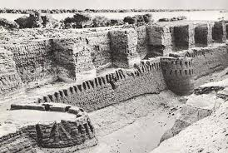
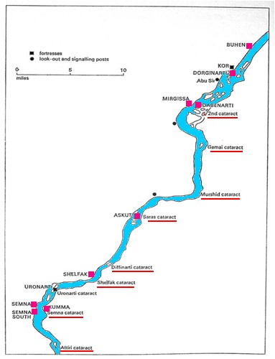

Figure 2. The huge fortress of Buhen built by pharaoh Sesostris III at north of the 2nd Cataract.

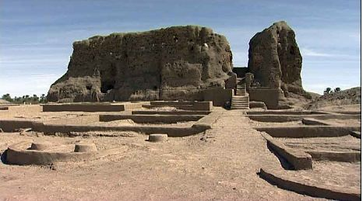

Figure 1. The Egyptian fortresses built from the 2nd Cataract to the 3rd Cataract of the Nile.
Fig. 3. The Deffufa temple of the Kushite royal city of Kerma south of the 3rd Cataract.

3. The kingdom of Kerma during the 2nd Intermediate Period (ca. 1650-1500)
However, the bellicose neighbour of Egyptians continued all along the following centuries to threaten the south border of Egypt. At the end of the 17th dynasty (1575-1525 B.C.), Sobeknakht II, nomarch of the city of Nekheb (present El Kab in Upper Egypt) reported on the walls of his tomb how he successfully resisted to an attack of the ruler of Kush and its allies from the Land of Punt, and finally expelled the invaders (El-Aref, 2003). Moreover, a few years later the Hyksos king Apophis Aâwserre tempted to obtain an alliance with the Kushite ruler of Kerma in order to encircle the frail Theban kingdom. Fortunately, at this time the regent prince Kamose general in chief of the Theban armies intercepted the messenger and conquered the desert in order to impede the junction of the two enemies of Egypt (Habachi, 1972). Finally, Kamose succeeded in taking the city of Avaris, the capital of Hyksos who were definitely expelled from Egypt by the new Theban king Ahmose Nebpehtyre, first pharaoh of the 18th dynasty.

4. The struggles of the New Kingdom (ca. 1500-1100)
Nevertheless, Kushite rulers tempted several times more to conquer Egypt. An Egyptian military officer Ahmes son of Ebana reported on the walls of his tomb in El Kab (Redford, 1997) that King Ahmose sailed to Upper Nubia, south of the Second Cataract, to destroy the Nubian bowmen : “His Majesty made a great slaughter among them". Returning from this skirmish in Nubia, the king was confronted with two adversaries in Upper Egypt. One of these was an Egyptian, Teti-an, who seems to have led a genuine uprising. The other adversary was named Aata, a rebel. This Aata apparently "came to the South (from Egypt)" and seems to have commanded only one ship and accordingly only few men. He was defeated and his men were captured alive to be handed out as rewards for the Egyptian soldiers. “His Majesty carried him off as a living captive and all his people as booty”. The troubles with Aata and Teti-an in Upper Egypt and Lower Nubia seem to have been the last real obstacles for the resurrection of a powerful Egyptian state, ushering in the New Kingdom. From that time Kush « the South Lands » was administered under the control of Egypt.
5. The conquests of Thuthmose I and his imperialist successors
From the reign of king Thuthmose I (1504-1492) Kushite people were completely subdued for a long time. The pharaoh seems to have begun the fight as soon as he ascended the throne although he was already aged. The officer Ahmes son of Ebana (Redford, 1997) reported how he participated to an expedition beyond the Third Cataract where Thutmose I engaged a Nubian king in hand to hand combat and slew the Nubian. Upon victory Thutmose I had the Nubian king's body hung from the prow of his ship, before he returned to Thebes. After that campaign, he led a second expedition against Nubia in his third year of reign, in the course of which he ordered the canal at the first cataract, which had been built under Sesostris III of the 12th Dynasty, to be dredged in order to facilitate easier travel upstream from Egypt to Nubia. This helped to integrate Nubia into the Egyptian empire. Under this reign, a viceroy, Tury, vassal of the Egyptian king, governed Nubia. With a civilian representative of the king permanently established in Nubia itself, the Land of Kush did not dare to revolt as often as it had and was easily controlled by future Egyptian kings.
Thuthmose I was responsible for a number of monuments in Upper and Lower Nubia. We believe that there are several structures that may date from his reign near Kenissa at the Fourth Cataract and at Napata. He had founded Dukki Gel (Pnubs) where he built two temples. Traces of ruins also exist at Semna, Buhen, Aniba, Quban and Qasr Ibrim, though most of these were probably small, or additions to earlier buildings. After him, his daughter Queen Hatshepsut, the wife of Thuthmose II, oversaw the preparations and funding for a trading expedition to the Land of Punt in her nineteenth year of reign. Most notably, the Egyptians returned from the voyage bearing thirty-one live myrrh trees, the roots of which were carefully kept in baskets for the duration of the voyage. Egyptians also returned with living Puntites (Punt is supposed to be Somalia) (Fig. 4).
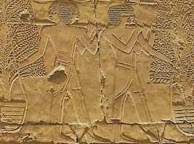

Figure 4. Transport of incense trees brought back to Egypt from the Land of Punt by order of Queen Hatshepsut (Thuthmose Ist’s daughter ).

King Thuthmose II died young. His successor Thutmose III attacked Nubia in his fiftieth year of reign. He went so far as the Fourth Cataract of the Nile and built a temple at Gebel Barkal. No king of Egypt had ever penetrated as far as he did with an army, although Thuthmose I left his cartouche on the same quartz block in Kurgus (Hager el Merwa) (Fig. 5 and 6) (Vercoutter, 1956) . Thuthmose IV suppressed a minor uprising in Nubia in his 8th year attested in his Konosso stela around 1393 B.C. This stele (Vercoutter, 1956) appears to refer to a minor desert patrol action on the part of the king's forces to protect certain gold-mine routes in Egypt's Eastern Desert from occasional attacks by the Nubians. Similarly, Amenophis III had to quell a revolt in Nubia in the 5th year of his reign. However, he built a temple at Soleb, a small temple with a colonnade dedicated to Thuthmose III at Elephantine, a rock temple dedicated to “Amun Lord of the Ways” at Wadi es-Sebuam, and the temple of Horus of Miam at Aniba, as well as founding additional temples at Kawa and Sesebi.

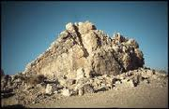

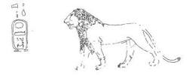

Figure 5. The quartz rock of Hager el Merwa near Kurgus between the 4th and the 5th Cataract of the Nile
Figure 6. The cartouche of Thuthmose III shown as a standing lion engraved in the quartz rock.

6. The Ramesside floruit in Nubia (ca.1296-1069 B.C.)
After the end of the offspring of Thuthmose I, the pharaohs of the 19th dynasty continued to reign on the Land of Kush governed by viceroys called “King’s son of Kush” (Fig. 7). The Egyptian army put down a minor rebellion in Nubia in the 8th year of Seti I. Seti himself did not participate in the expedition, although his Crown Prince, the future Ramses II may have. Succeeding to his father, Ramses II also campaigned south of the First Cataract into Nubia.
By the time of Ramses, Nubia had been a colony of Egypt for two hundred years, but its conquest was recalled in decoration of the temples Ramses II built at Beit el-Wali, Gerf Hussein and Kalabsha in northern Nubia. On the south wall of the Beit el-Wali temple, Ramses II is depicted charging into battle against the Nubians in a war chariot, while his two young sons, Amunherkhepsef and Khaemwaset, are shown being present behind him, also in war chariots. Indeed, he needed to continue to exploit the wealth of Nubia, mainly gold and incense for the temples. As soon as his first regnal years, he submitted tribes of Wawat (Lower Nubia) and Kush, as shown on the forecourt of the small temple of Beit el-Wali near Aswan. From the quarries of this region, he obtained the obelisks and statues, which adorn his monuments of Lower and Upper Egypt. To protect his historical frontier with Kush he restored the fortresses built in the Middle Kingdom in Buhen, Semna et Kouma, south of the First Cataract and built a series of rock-temples to god Amun in Wadi es-Sebwa, to Ptah in Gerf Hussein, to Ra in Derr. He erected the two great sanctuaries of Abu Simbel : one devoted to his favorite wife Nefrotari, and the other one devoted to the gods protecting his kingdom, Amun, Ptah and Ra ; but also to himself represented as a god with a falcon head.
However, after him his successors of the 19th and 20th dynasties, facing invasions of Egypt come from the North, will gradually lose their control over the Land of Kush.

7. The Kushite pharaohs of the 25th dynasty in Egypt (ca.760-656 B.C.)
After the extinction of the Egyptian 20th dynasty, new lineages of kings from Libyan origin spared the power on Egypt (21st to 24th dynasties). In the meantime, a new dynasty of Kushite rulers originating from Napata emerged in the region of the Fourth Cataract. So that, the Kushite king Piankhy (or Piye) invaded Egypt as far as Memphis and was the founder of the 25th dynasty which reigned both on Kush and Egypt for nearly one century. Taharqa the 4th black pharaoh of the 25th dynasty has spread his empire from the South of Khartum to Lebanon in the North (Fig. 7).
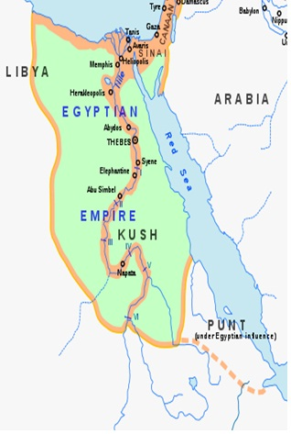

Figure 7. The Egyptian Empire under the rule of the black pharaohs of the 25th dynasty reigning both on Egypt and the Land of Kush.

These Kushite pharaohs have fully embraced the Egyptian culture and exported traditions of pharaonic Egypt into Nubia. Egyptian artisans were involved in the construction of the Nubian temples, including Napata and Kawa. To their graves, the Kushite kings adopted the pyramid (in Kurru and Nuri) (Figure 8). In Egypt, they scrupulously respected the customs and institutions, asserting to be fully Egyptian, while keeping their black African characters in their portraits. We note traditional scenes of royal triumph showing Kushite prisoners under the control of the Nubian pharaoh. However, they managed to ensure their control over the Theban clergy by involving the Nubians. The “Divine Worshipper” priestess in place in the Karnak Amun temple should adopt a daughter of king Kashta, Amenirdas, to succeed her; and Kushite princes were integrated to the clergy of Amun at Thebes alongside with members of the great Theban families. This period is manifested by an intense intellectual and artistic activity, searching for references in ancient forms of the past, particularly in the Egyptian Old Kingdom. The Kushite power, eager to fit the institutional pharaonic model dealt with the Egyptian elite, and undertook an active politics valorising temples.
However, the successor of Taharqa, king Tanutamun was finally expelled from Egypt by the Assyrian king Assurbanipal. Nevertheless, the Kushite rulers continued to reign on Upper Nubia from their residence of Napata for sixty six years.
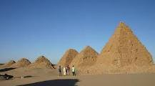
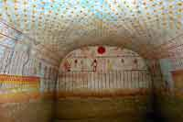

Figure 8. Nubian pyramids at El Kurru near Djebel Barkal
Figure 9. Burial chamber of the pyramid of pharaoh Tanoutamun and his mother Queen Qalhata at El Kurru.

8. The 26th dynasty’s campaigns against Kush

After the departure of the last Kushite king out of Egypt, pharaoh Psamtik I (664-610) of the 26th dynasty of Sais had to maintain a garrison of 250,000 soldiers to guard his frontier in Elephantine near the First Cataract. Herodotus (II, 30) reported that, as they were not replaced for three years, these soldiers deserted and passed to the service of the king of Kush who gave them a land to install after they drove out the previous inhabitants who were his enemies. Plato himself (Timaeus 25c) said that after most of the Greek soldiers of the defensive alliance have deserted, only Athenians continued to fight Atlantes (Kushites).

Finally, his grandson Psamtik II (595-589 B.C.) hearing that Kush intended to attack Egypt one time more, decided to quell this recurrent problem by a radical military campaign. General Amasis conducted the Egyptian troops, which were reinforced by a corps of Egean mercenaries led by general Potasimto (Bonnet, C. and Valbelle, D., 2005; Grimal, 1988; Lefebvre, 1925; Sauneron and Yoyotte, 1952; Török, 1997). Three steles in hieroglyphs found in Shallal, Karnak and Tanis (Der Manuelian, 1984) report this expedition, which spread from 593 to 591 B.C. (Fig. 10). The king himself stopped in Elephantine at the level of the First Cataract at Aswan. But his troops reached Napata and burnt the temples of Djebel Barkal, the sacred city of Kush. Psamtik II celebrated this triumph with glare and great pomp, but curiously, he does not appear to have capitalized on his victory. His troops retreated to the First Cataract, and Elephantine continued to be the southern border of Egypt. An outcome of this campaign was the deliberate destruction of monuments belonging to the 25th dynasty of Kushite kings in Egypt "by hacking out their names and the emblems of royalty from their statues and relieves."
Because of Psamtik II's devastating campaign, Kush power crushed and its kings lost any opportunity of ever regaining control of Egypt. Instead, king Aspelta (600-580) decided to shift his capital further south, from Napata near the Fourth Cataract to Meroe 300 km in the South, beyond the Fifth Cataract far from the Egyptian power (Ghembaza, 2011).
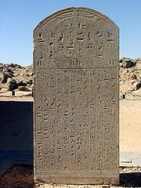

Figure 10. Stele in Shellal reporting the campaign of Psametik II against Kush.
10. CONCLUSIONS
When Solon came to Sais ca. 560 B.C., there was only three decades of years that king Aspelta had moved his residence to Meroe and rebuilt the most ancient metropolis of Kush (Rilly, 2010). As Plato said (Critias 115e): “First of all they bridged over the zones of sea which surrounded the ancient metropolis, making a road to and from the royal palace. And at the very beginning they built the palace on the place where have lived the god and their ancestors”. This really corresponds to the second phase of settlement of the city of Meroe in the 6th century B.C., as evidenced by archaeological digging (Bradley, 1984).
REFERENCES
Bonnet, C. and Valbelle, D. (2005) L'expédition militaire de Psammétique II. In: Bonnet, C. and Valbelle, D., (Eds.) Des pharaons venus d'Afrique - La cachette de Kerma, Paris : Citadelles & Mazenod, pp. 164-170.
Bradley, R. (1984) Meroitic chronology. Meroitica 7, 195-211.
El-Aref , N. (2003) Elkab's hidden treasure. Al Ahram Weekly On-Line, Heritage, 31 July - 6 August 2003. http://weekly.ahram.org.eg/2003/649/he1.htm
Ghembaza, T. (2011) Plato’s atlantida nesos as the “Island of Meroe”. Part I. The reason why Egyptians were so friendly with the Greek Solon… In: Papamarinopoulos, S.T., (Ed.) Proceedings of the 2nd International Conference on “The Atlantis Hypothesis” (Atlantis 2008). Athens : Heliotopos Ltd. pp. 491-496.
http://127.0.0.1:8080/ANTIQUA/web_sites/site_1/resources/cariboost_files/MeroeCHAPITRE_20I_2021_20september_202009.doc
Grimal, N. (1988) Éthiopiens et Saïtes . In: Grimal, N. (Ed.) Histoire de l'Egypte ancienne, Paris: Fayard. pp. 431-471.
Habachi, L. (1972) The second stela of Kamose and his struggle against the Hyksos ruler and his capital, Glückstadt: J.J. Augustin
Lefebvre, G. (1925) Potasimto (Le général Pedi-sema-taoui, commandant des mercenaires de Psammétique II). Bulletin de la Société Archéologique d'Alexandrie 21, 48-57.
Redford, D. (1997) Textual Sources for the Hyksos Period. In: Oren, E.D., (Ed.) The Hyksos: New Historical and Archaeological Perspectives,. Philadelphia: University of Pennsylvania. pp. 1-44. http://www.u.arizona.edu/~afutrell/w%20civ%2002/kamose.html
Rilly, C. (2010) Le royaume de Méroé. Afriques [On line], Varia, 1-23 ; http://afriques.revues.org/379.
Sauneron, S. and Yoyotte, J. (1952) La campagne nubienne de Psammétique II et sa signification historique. Bulletin de l'Institut Français d'Archéologie Orientale (BIFAO) 50, 157-207.[ On-line] http://www.ifao.egnet.net/bifao/50/
Török, L. (1997) The Nubian campaign of Psamtik II in 593 B.C. In: Török, L., (Ed.) The kingdom of Kush. Handbook of the Napatan Meroitic civilization, Leiden: Brill. pp. 360-362, 371-374. [On line] http://books.google.fr/books?id=i54rPFeGKewC&printsec=frontcover&source=gbs_v2_summary_r&cad=0#v=onepage&q=&f=false
Vercoutter, J. (1956) New Egyptian texts from the Sudan. Kush 4, 66-82.
Figure 6. Meroitic archaeologic sites

